



**SM6P07NI Digital Media Project**

**50% Individual Coursework**

**2024-25 Autumn**

**Student Name: Sarina Jimi**

**London Met ID: 22015940**

**College ID: NP01MM4S220014**

**External Supervisor: Saugat Basnet**

**Internal Supervisor: Parbat Bhujel**

**Assignment Due Date: 7 May 2025**

**Assignment Submission Date: 7 May 2025**

|  |  |
| --- | --- |
| **One Drive Link** | [Digital Media Project](https://islingtoncollegeedunp-my.sharepoint.com/:f:/r/personal/np01mm4s220014_islingtoncollege_edu_np/Documents/Digital%20Media%20Project?csf=1&web=1&e=DBZEzs) |
| **YouTube Link** | **https://youtu.be/R2qPIqCggQc** |
| **Github Link** | **https://github.com/Sarina2025/DMP.git** |

*I confirm that I understand my coursework needs to be submitted online via Google Classroom under the relevant module page before the deadline in order for my assignment to be accepted and marked. I am fully aware that late submissions will be treated as non-submission and a marks of zero will be awarded.*

**Table of Contents**

1. Introduction 1

1.1 Topic 1

1.2 Area of Research 1

2. Aims of Project 2

3. Project Proposal 3

4. Target Audience 4

5. Technologies Employed 5

5.1. Software Tools 5

5.2. Hardware 5

6. Product Research 7

7. Project Plan 12

8. Production Phases 13

8.1 Pre-Production 13

8.1 Production 14

8.1 Post-Production 25

10. User Testing & Findings 52

10.1 Survey Form 52

10.2 Survey Findings 56

10.3 Third Party Evaluation 57

Conclusion 58

References 59

Appendix 60

**Table of Figure:**

Figure 1: Technologies employed 5

Figure 2: Hardware specification 6

Figure 3: Hardware tool 6

Figure 4: Product Research 1 7

Figure 5: Product research 2 8

Figure 6: Product research 3 10

Figure 7: Product research 4 11

Figure 8: Old Gantt Chart 12

Figure 9: New Gantt Chart 12

Figure 10: Script 13

Figure 11: Screenshot 1 14

Figure 12: Screenshot 2 14

Figure 13: Screenshot 3 15

Figure 14: Screenshot 4 16

Figure 15: Screenshot 5 17

Figure 16: Screenshot 6 17

Figure 17: Screenshot 7 18

Figure 18: Screenshot 8 19

Figure 19: Screenshot 9 20

Figure 20: Screenshot 10 21

Figure 21: Screenshot 11 22

Figure 22: Screenshot 12 23

Figure 23: Screenshot 13 24

Figure 24: Screenshot 14 25

Figure 25: Screenshot 15 26

Figure 26: Screenshot 16 27

Figure 27: Screenshot 17 28

Figure 28: Screenshot 18 29

Figure 29: Screenshot 19 30

Figure 30: Screenshot 20 31

Figure 31: Screenshot 21 32

Figure 32: Screenshot 22 33

Figure 33: Screenshot 23 34

Figure 34: Screenshot 24 35

Figure 35: Screenshot 25 36

Figure 36: Screenshot 26 37

Figure 37: Screenshot 27 38

Figure 38: Screenshot 28 39

Figure 39: Screenshot 29 40

Figure 40: Screenshot 30 41

Figure 41: Screenshot 31 42

Figure 42: Screenshot 32 43

Figure 43: Screenshot 33 44

Figure 44: Screenshot 34 45

Figure 45: Screenshot 35 46

Figure 46: Screenshot 36 47

Figure 47: Screenshot 37 48

Figure 48: Screenshot 38 49

Figure 49: Screenshot 39 49

Figure 50: Screenshot 40 50

Figure 51: Screenshot 41 50

Figure 52: Screenshot 42 51

# 1. Introduction

This module is about helping students learn how to plan, research, and create a digital media project. For this project, the main focus is on using motion graphics to make a television commercial (TVC). Motion graphics means using text, pictures, and animation to show information in a simple and clear way (Provost, 2023).

The project explores how motion graphics can show the journey of fresh produce from farms to homes through Farmshop, while also promoting the Farmshop app. After doing research, Adobe software like After Effects, Photoshop, and Premiere Pro were chosen because they fit the needs of the project. Research was also done to select characters, props, and backgrounds that fit the story well.

This is a client-based project in collaboration with Farmshop. It uses motion graphics to promote the brand and its app by highlighting Farmshop’s focus on healthy eating, sustainability, and supporting local farmers. The goal is to make people more aware of the brand and show how easy the app is to use, so more people are encouraged to try it.

## Topic

The title of my project is “Farmshop: Connecting Farms to your home”. This title is chosen because the video aims to show just how fresh and organic the produce that you get at Farmshop is. By creating a captivating video that blends 2D animation, motion graphics and text narration smoothly, it will promote the brand as well as their app from which the customers can order fresh produce.

## Area of Research

The main research topic was about visual storytelling and motion graphics. Before concluding what was required, research was done one the software to be used, character design, narrative development and so on. The goal was to use motion graphics to visually show the benefits f Farmshop in an engaging and informative way. This project aimed to discover the tools, techniques and storytelling methods necessary to create an interesting and easy to understand motion graphic video.

# 2. Aims of Project

The primary aim of this project is to create a TVC/motion graphics video, which is both engaging and informative, for Farmshop, a business that delivers fresh produce directly from farms to customers. The video will show the journey of the produce. Additionally, it will highlight the simplicity and convenience of using the Farmshop mobile app to order fresh items.

The purpose of the project is to enhance brand awareness by helping people understand what Farmshop does and how it works. By using a colourful, animated format to show the entire journey, the video will make the concept of fresh , farm-sourced shopping more accessible and appealing to a wide range of viewers.

Once released, the video will accomplish some of the key objectives. It will attract potential customers by showing the transparency and efficiency of the service, it will show that the app is easy to use and that the food is really fresh which will lead to more app downloads. These objectives will be accomplished by the colourful graphics, smooth animations and a clear narrative structure that will simplify the complex process into a visually engaging format.

Furthermore, this project will also show that motion graphics can be used to tell a story and explain things better than just text or photos. It will help Farmshop by serving as a marketing tool to make the brand stand out.

# 3. Project Proposal

**Project Title**

Working title: Farmshop: Connecting Farms to your home.

The project is a TVC/motion graphics video for “Farmshop”, a shop that gets fresh produce straight from farms. The video will showcase the journey of the produce from the farm to the shop and then to the customer’s house. Additionally, it will promote their app, showing its user-friendly features and the ease with which the customers can order fresh produce through it.

**Research Question**

How can motion graphics be effectively used to visually narrate the journey of fresh produce from farms to customers’ homes while promoting the usability and convenience of a digital app?

**Treatment**

As the video starts, viewers can see fresh produce being picked from farms, showing lush, green farms and farmers working. Smooth animations guide the viewers to the process of the produce being sorted, packed, and delivered to the Farmshop’s shelves. Next, it shows someone using the Farmshop app, highlighting how easy it is to order. Finally, the produce arrives at the customer’s home, and they are happy with the fresh delivery. The animations are colourful and smooth, with simple music to make it more fun and easy to watch. It shows how Farmshop makes getting fresh produce simple and reliable.

# 4. Target Audience

The project’s target audience is primarily going to be those who are too busy to travel and search for good, organic produce, as well as those who work from home. It is also for people who are health conscious enough to prefer organic produce. This demographic means that the range of people is going to those who are old enough to work and are busy with work.

* Age:

In terms of age, the target audience ranges from people who have just started to work to people who have been in the working field for a very long time. People who are health conscious is also included whether they be teenagers or adults.

* Gender:

In terms of gender, it is a video that is not exclusive to any one gender. Both male, female or any other gender can be influenced by the video.

* Ethnicity and Location

Regarding ethnicity, the project aims to reach individuals from diverse cultural backgrounds but for the location, only people who live in Kathmandu are targeted as it is organic produce which will rot the more distance it has to travel.

# 5. Technologies Employed

To make the project successful, some important tools were needed. A strong computer with good internet and enough power was necessary to run After Effects smoothly.

## 5.1. Software Tools

Different software was used for different parts of the project.

**Adobe Photoshop**

* Used to edit the resources/images used to make the motion graphic video.
* Create storyboard which help to plan out how the scene will look.

**Adobe Illustrator**

* Used to make the characters and backgrounds used to make the motion graphic video.

**Adobe After Effects**

* Used to edit all the scenes for the motion graphic video as well used to add the text narration and the background music.

.   

Figure 1: Technologies employed

## 5.2. Hardware

Laptop Specification:

* Predator Helios 300
* 11th Gen
* 16 GB RAM
* NVIDIA GeForce RTX 3060
* Windows 11

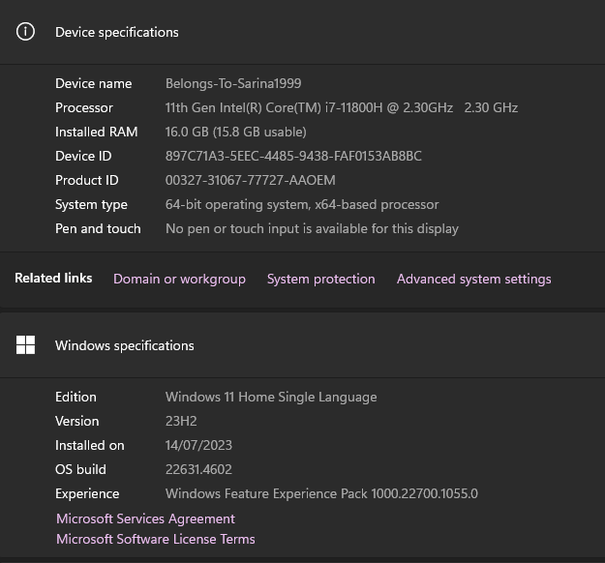

Figure 2: Hardware specification

Drawing Tablet:

* XP-PEN Deco 01 V2 Graphic Tab

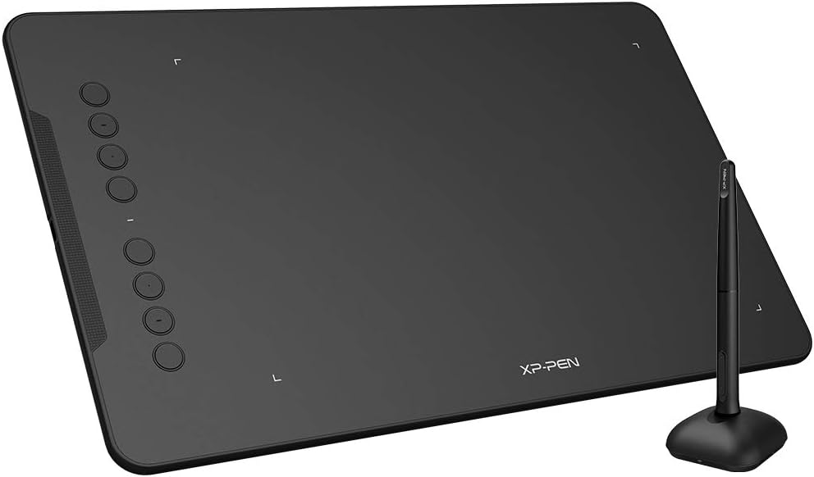

Figure 3: Hardware tool

# 6. Product Research

During the product research phase, different sources and methods were used to collect helpful information and materials. This helped build better understanding of the topic and how to use motion graphic effectively.

The research process included a detailed look at the Farmshop website to collect official information about its services, policies, and how it operates. Along with that, visits were made to the physical store to observe how things work. This hands-on experience gave useful insights into the real-life functioning of Farmshop and customer behaviour.

Also, different theories, techniques, and practices in and motion graphics were studied to help guide the creative process. This included looking at new media examples and product reviews to understand what works well in educational videos. By using what was learned from this research, the project was able to get a clear idea of the topic and use good storytelling and visual methods to make an interesting and informative motion graphic about how Farmshop works and what it offers.

* **Camera Moves in 2D Animation - How its done** (Storm, 2022)

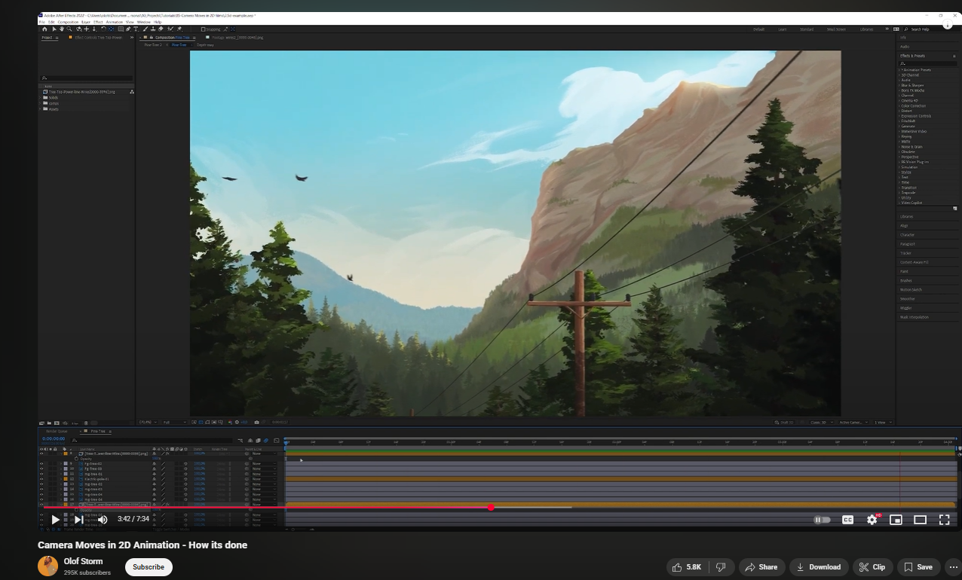

Figure 4: Product Research 1

In this video, various methods for creating the illusion of camera movement was explained with key techniques like parallax scrolling; using layered backgrounds that move at difference speeds to create a sense of depth, camera panning and zooming; using horizontal and vertical camera movements to guide viewer focus and add cinematic quality, and perspective shifts; altering the viewpoint within a scene to mimic camera rotations or tilts, enhancing the three-dimensional feel.

* **From farm to fork - sustainable food for our future** (Farming, 2017)

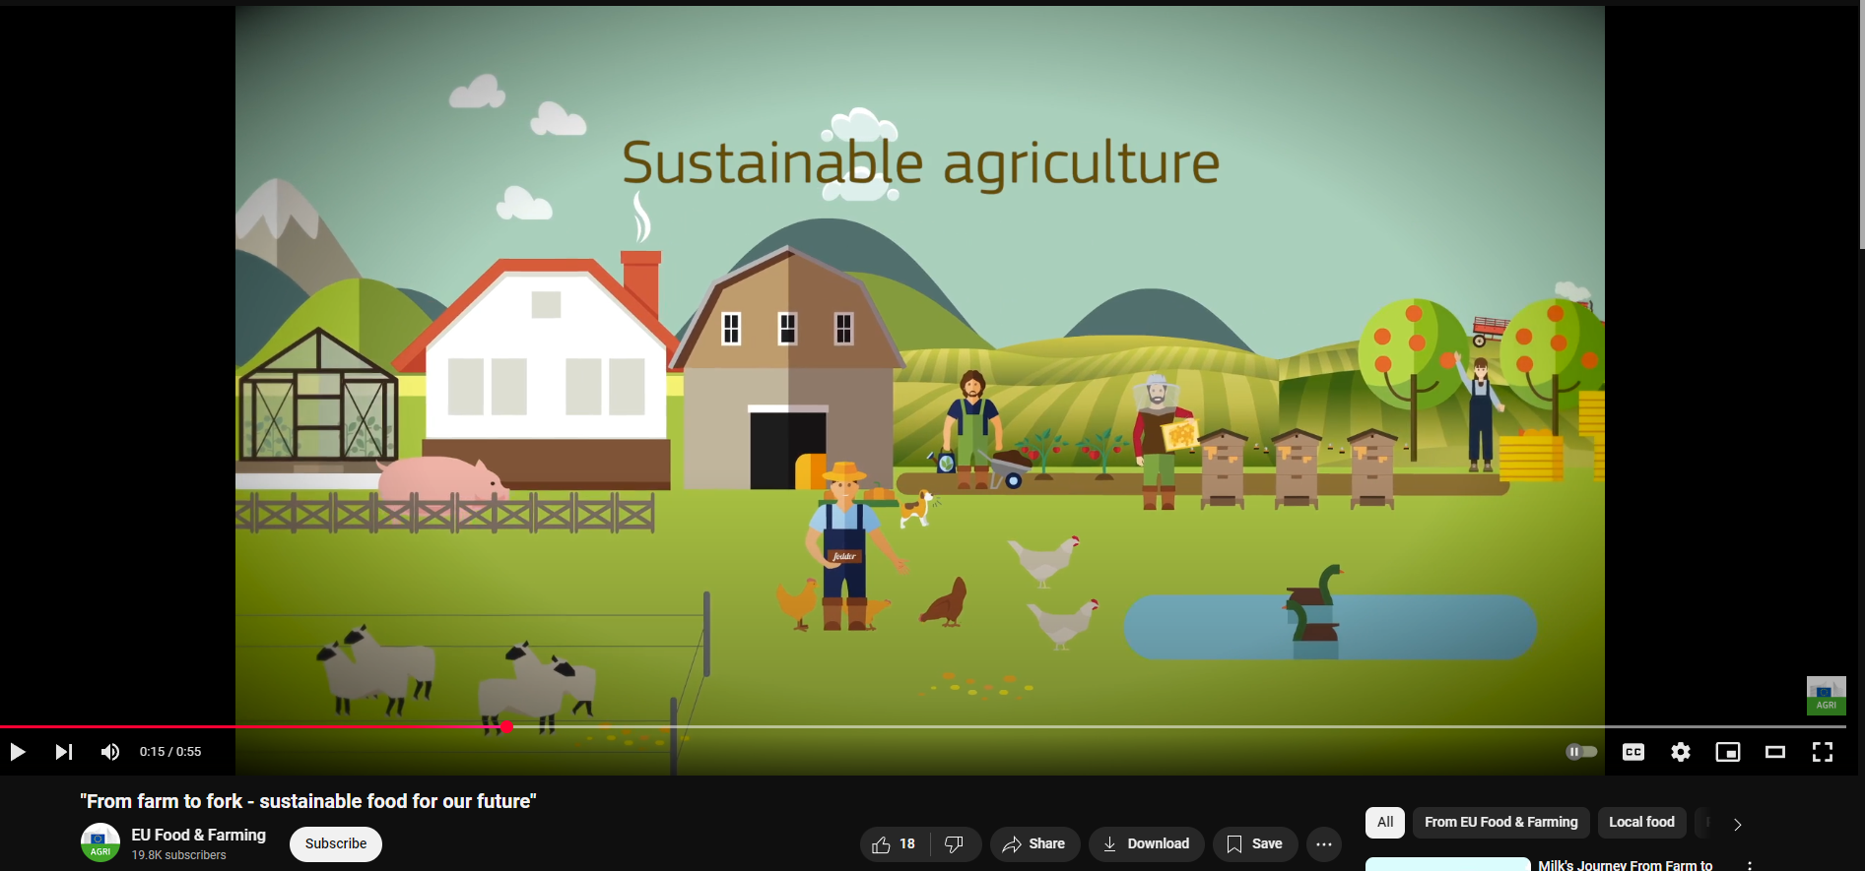

Figure 5: Product research 2

One of the strengths of the project is its clear storytelling. The journey of fresh produce from farm to table is shown in a way that’s easy to understand. The camera movements are smooth, making the visuals pleasant to watch. The use of bright, natural colors also adds to the appeal, giving the video a fresh and clean look. Additionally, the transitions between scenes help maintain the flow, making the video feel connected and organized.

However, there are also some areas that could be improved. The transitions, while helpful, lack variety and become repetitive after a while. There is also a noticeable absence of detailed animations showing the farmers or the actual origin of the products, which could have added more depth to the story. The video doesn’t include many effects or environmental visuals, which would have helped enhance the storytelling. Overall, the style is quite simple and doesn’t use any unique visual elements or creative techniques that would make it stand out more.

The video features smooth camera movements and bright, appealing visuals that help make the content easy to follow. However, it lacks the use of effects and creative transitions, which makes it feel a bit plain. The overall look is basic, and with more engaging visuals or variety in animation techniques, the video could have been more dynamic and interesting.

To improve the final output, it’s helpful to use smooth and fluid camera transitions, as they make the movement of the produce from one stage to another feel natural and connected. Keeping the narrative simple and focused on the farm-to-table journey helps viewers easily understand the story. Using close-up shots and adding detailed visuals of the produce at key points can highlight its quality and freshness, making the video more visually rich and informative.

* **Digitalisation of Agriculture** (CTA, 2020)

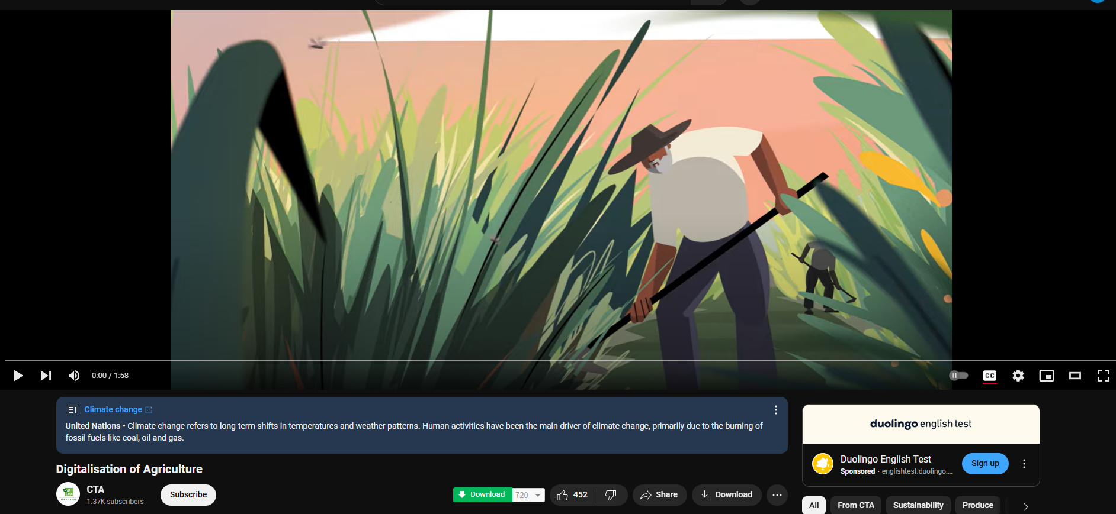

Figure 6: Product research 3

The video does a good job of keeping the motion smooth and continuous, which helps maintain the viewer’s attention. The voiceover is clear and easy to follow, explaining the content in a simple and concise way. However, the video tries to include too much information in a short amount of time, which can end up confusing the viewers.

The video uses smooth and seamless motion that helps keep the audience engaged throughout. The voiceover also works well, as it explains things clearly and is easy to understand. But because the video is packed with too much information, it ends up feeling a bit cramped, and the message doesn’t come across as clearly as it could have.

The voiceover style is inviting and should be kept the same for future versions. Also, using soft or subtle background motion is a good idea because it keeps the video visually active without taking attention away from the main message being shared.

* **Hydroponics Soi Farm | Explainer Video | Motion Graphics | By Creative Splash** (Splash, 2018)

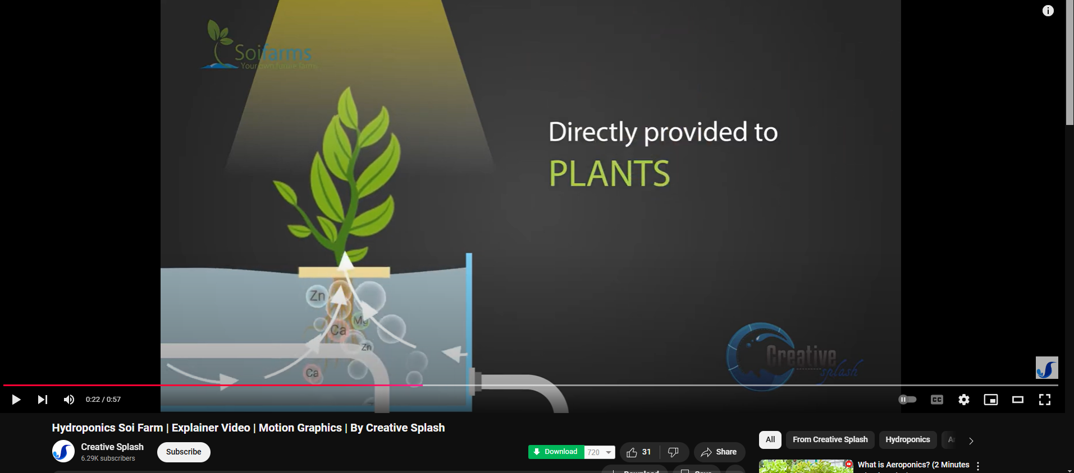

Figure 7: Product research 4

The video smartly uses hands to move images around, which gives it a nice human feel. The design is very clean, with only the graphics needed to explain the message, so viewers don’t get distracted. The text is spaced out well and clearly explains what’s happening. However, the narration feels a bit slow, and the way it's spoken has awkward pauses and strange tone changes.

Since the motion graphics are very minimal, the video does a good job of staying focused on the message. This helps viewers pay more attention to the information instead of getting lost in unnecessary visuals. The combination of clear text and simple animations makes it easy to follow. Still, the narration pulls it down a bit because the slow pace and odd voice inflection can make it feel less engaging.

To improve this, text should stay short and clear so it gets the point across quickly. Also, using too much animation can be distracting, so it's better to stick with simple motion that supports the topic rather than overloading the screen.

# 7. Project Plan

It took a bit more time for Motion graphics animation and the post-production evaluation but the narration part took significantly less time.

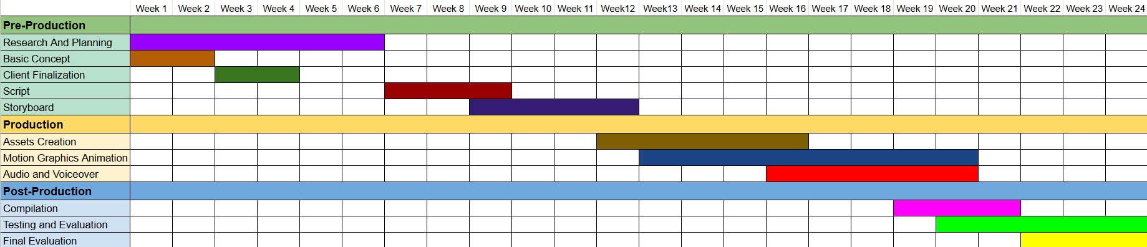

Figure 8: Old Gantt Chart

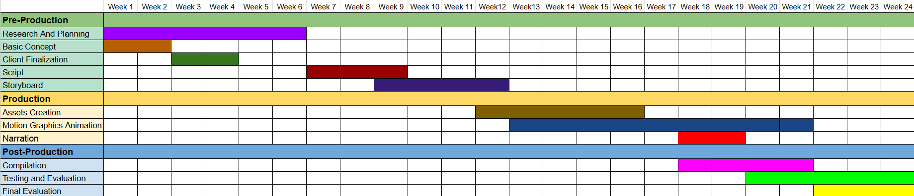

Figure 9: New Gantt Chart

# 8. Production Phases

## 8.1 Pre-Production

* Script

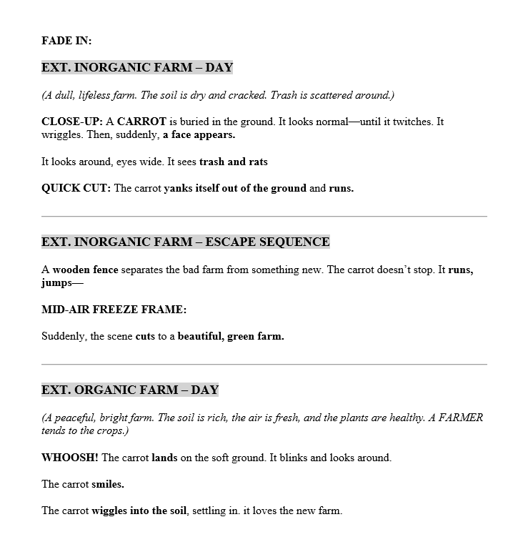

Figure 10: Script

## 8.1 Production

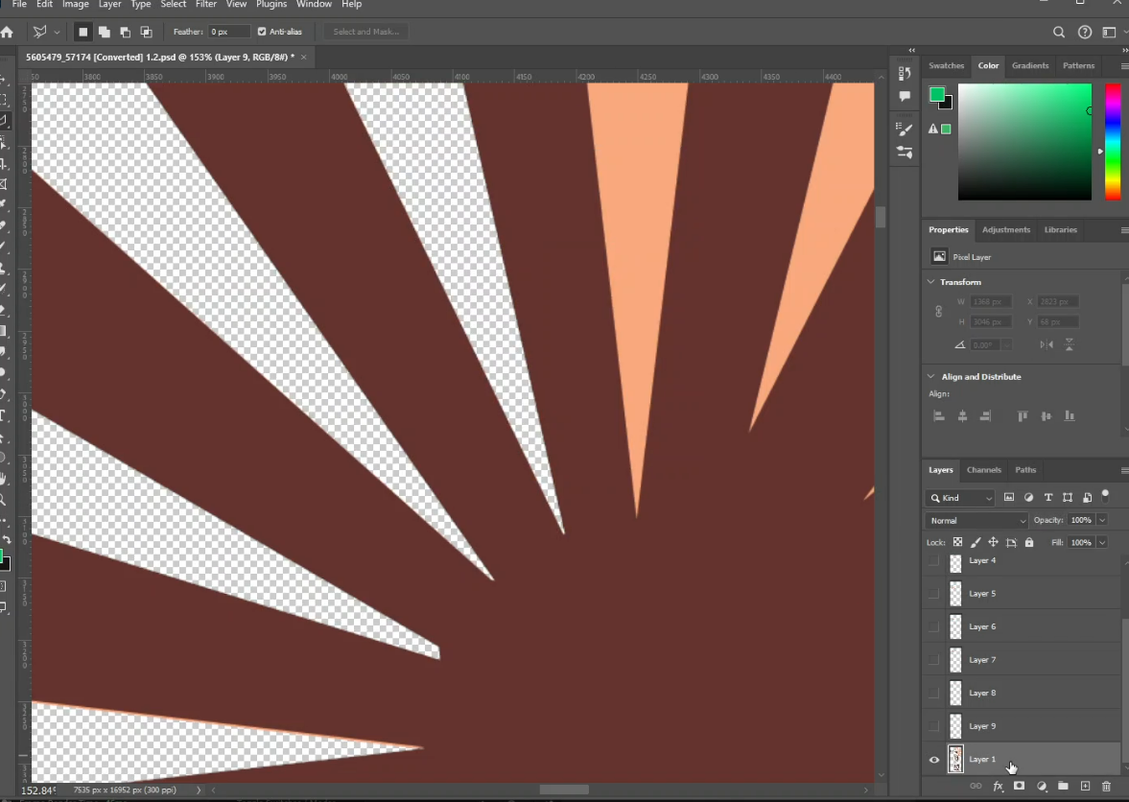

Figure 11: Screenshot 1

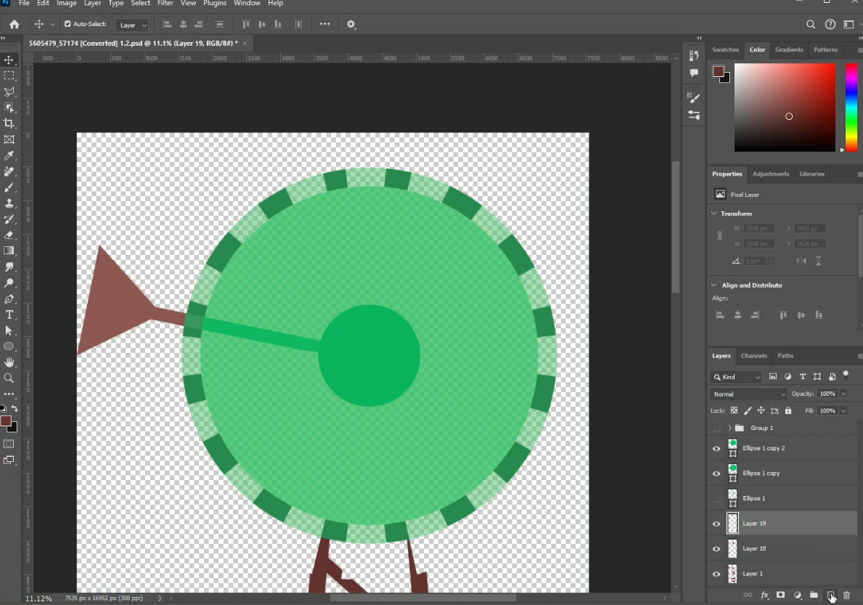

Figure 12: Screenshot 2

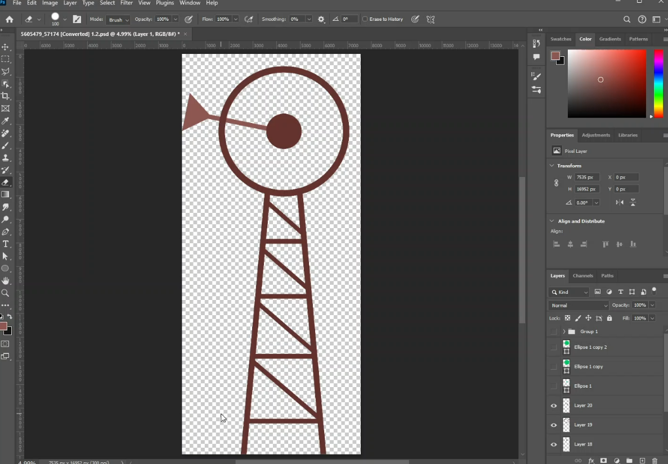

Figure 13: Screenshot 3

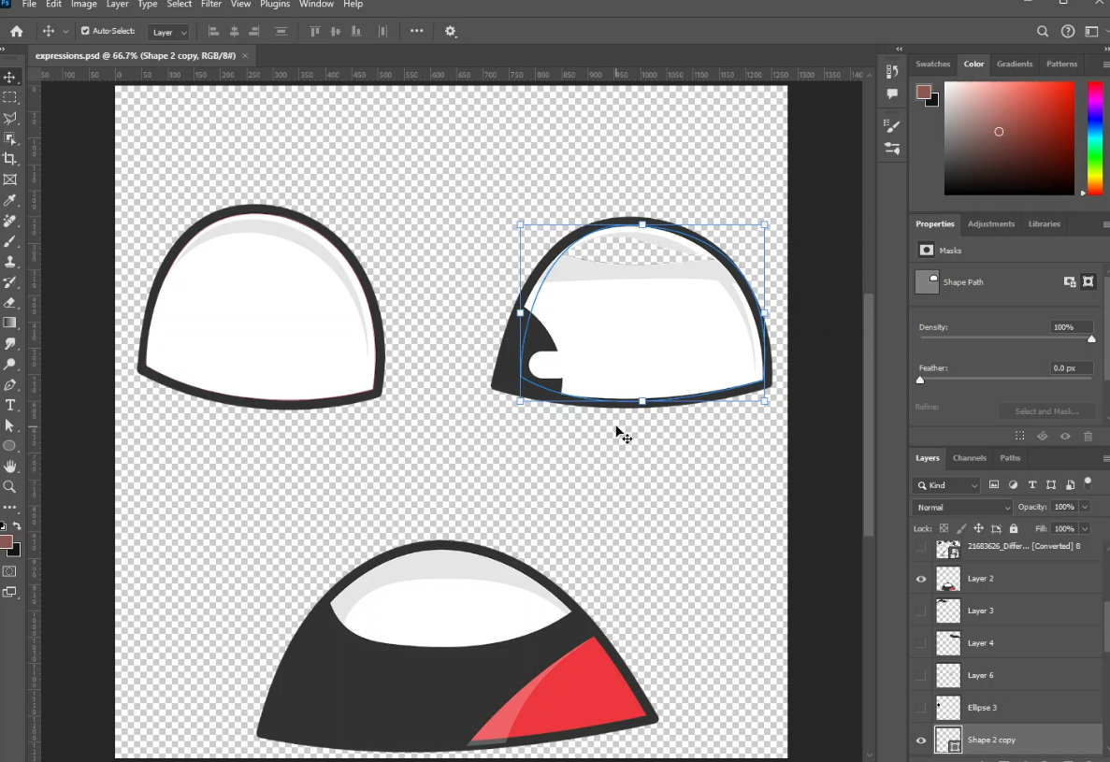

Figure 14: Screenshot 4

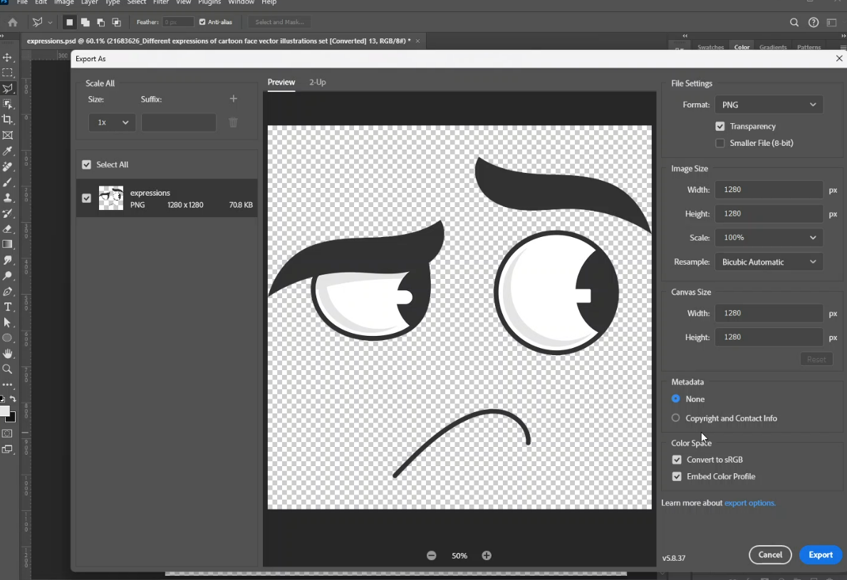

Figure 15: Screenshot 5

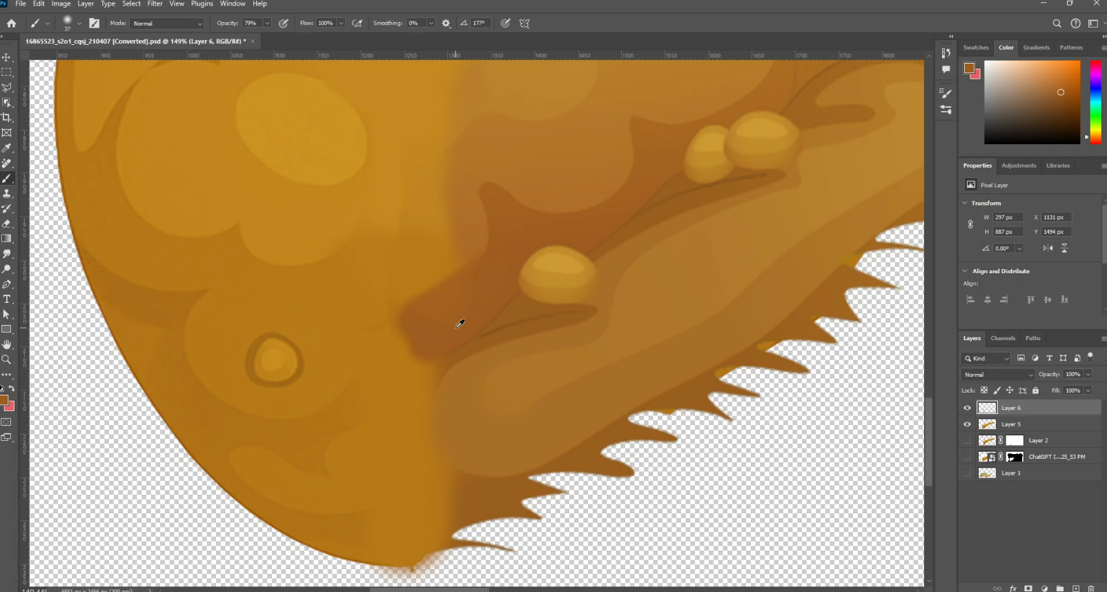

Figure 16: Screenshot 6

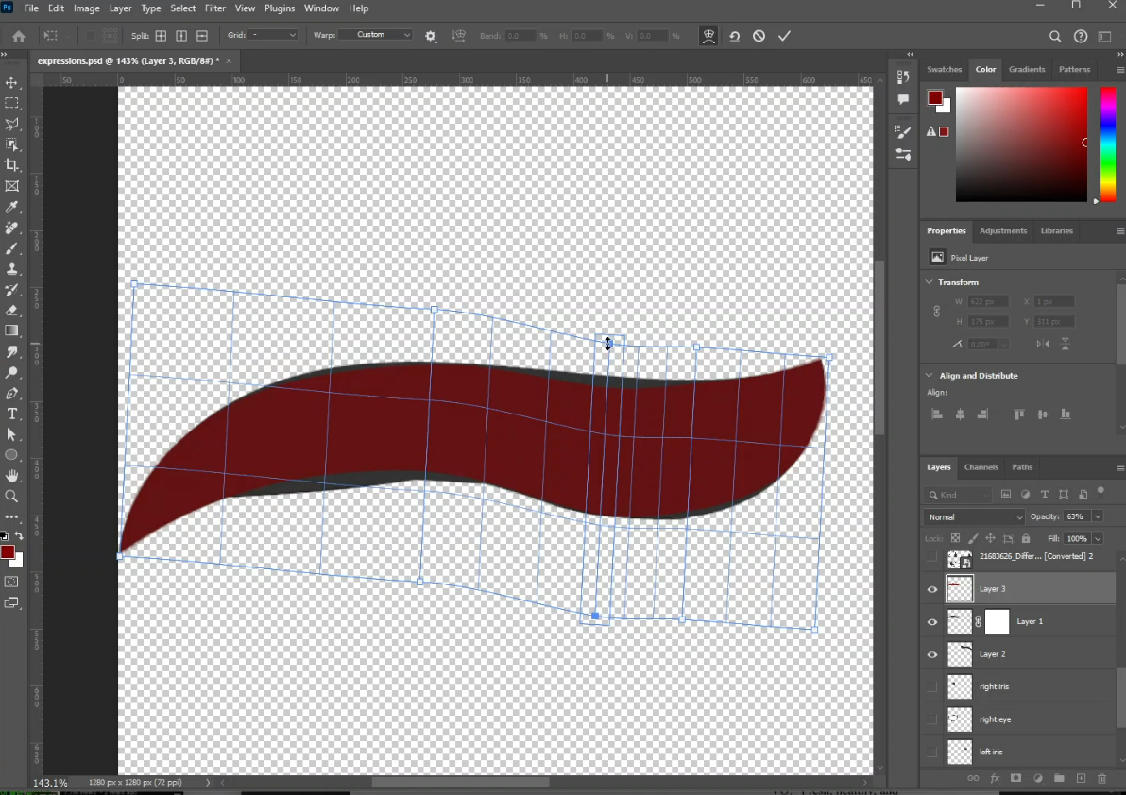

Figure 17: Screenshot 7

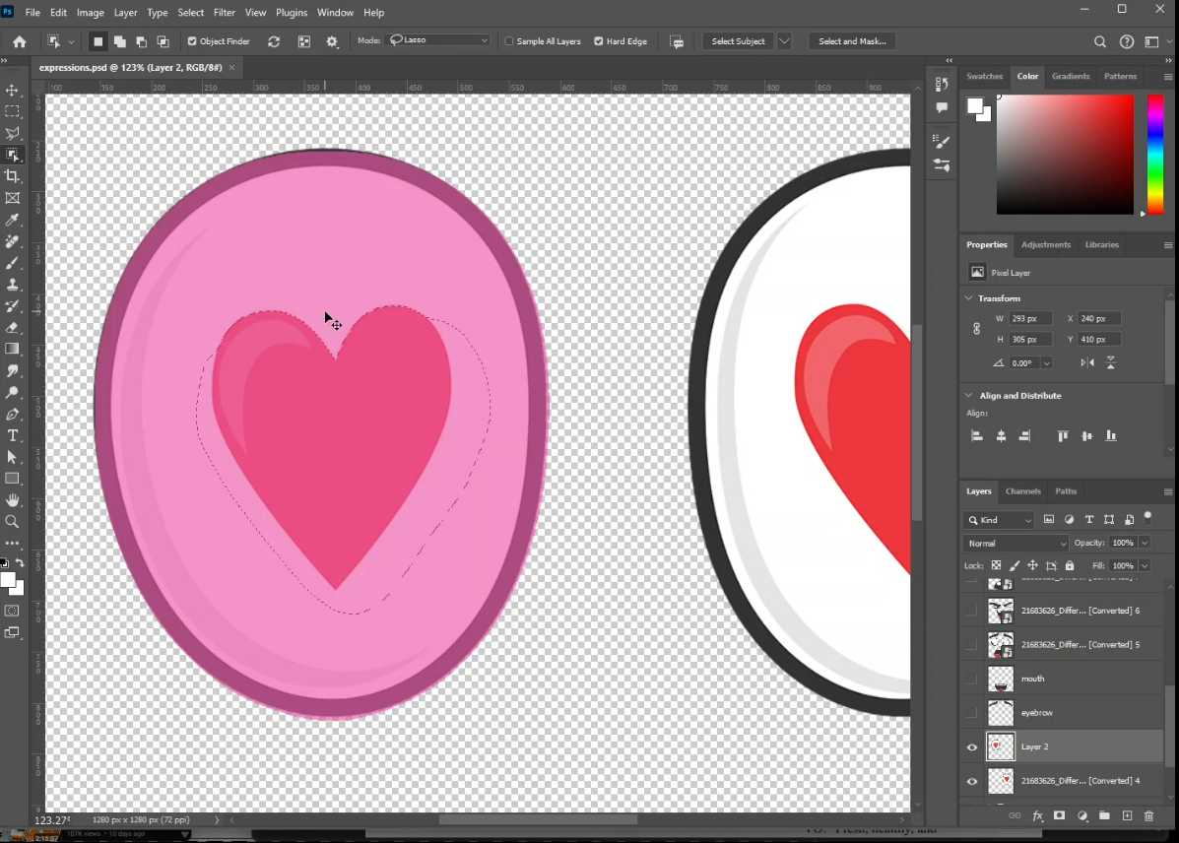

Figure 18: Screenshot 8

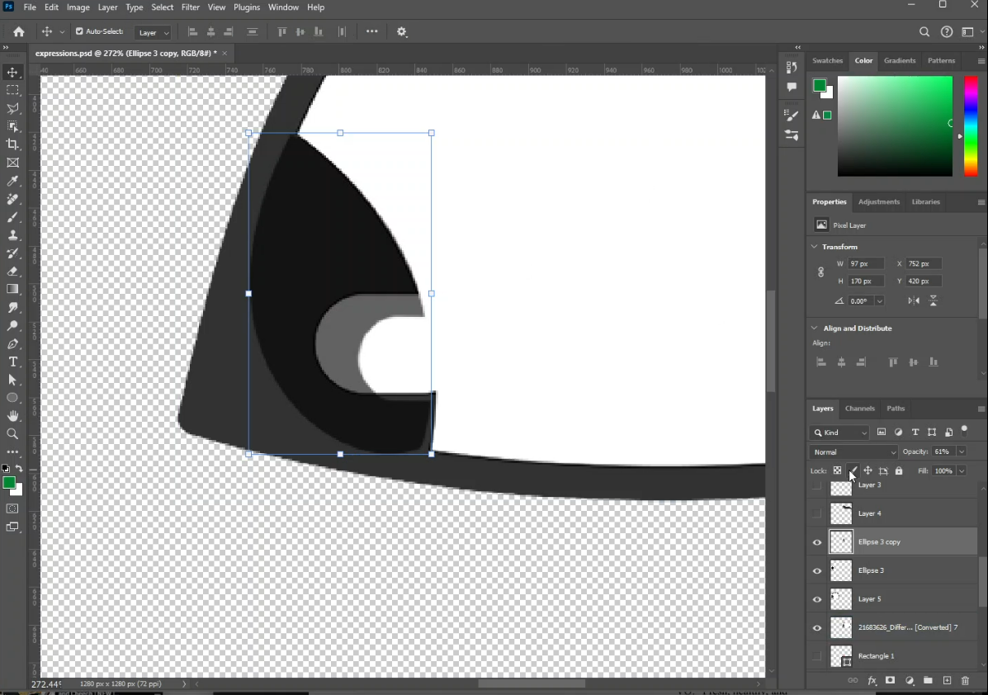

Figure 19: Screenshot 9

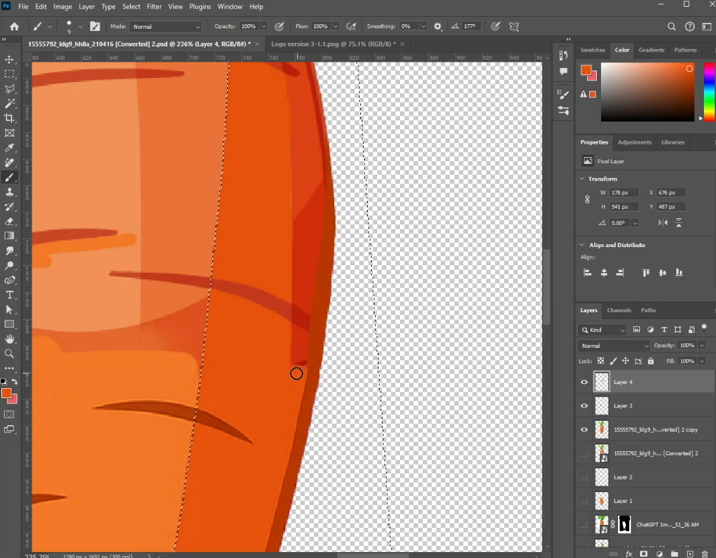

Figure 20: Screenshot 10

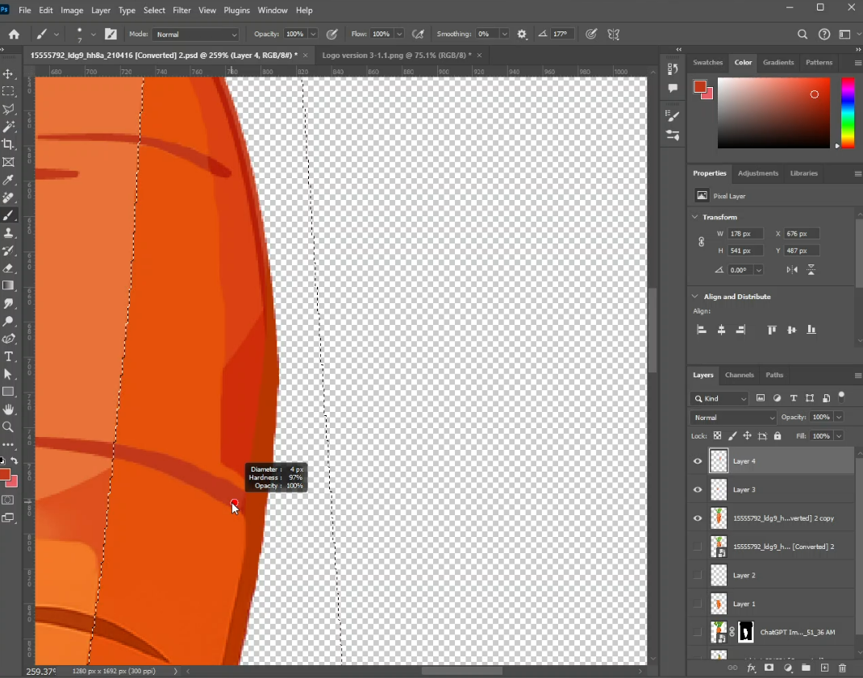

Figure 21: Screenshot 11

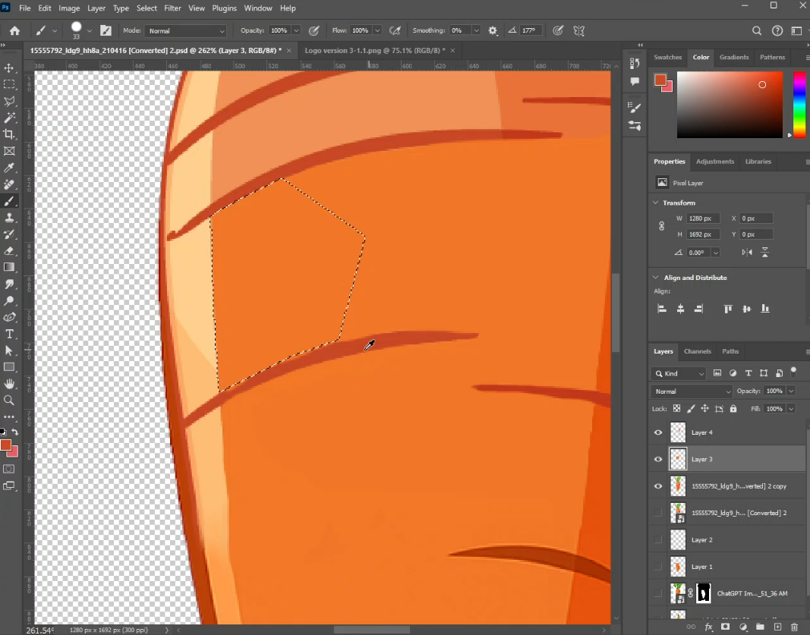

Figure 22: Screenshot 12

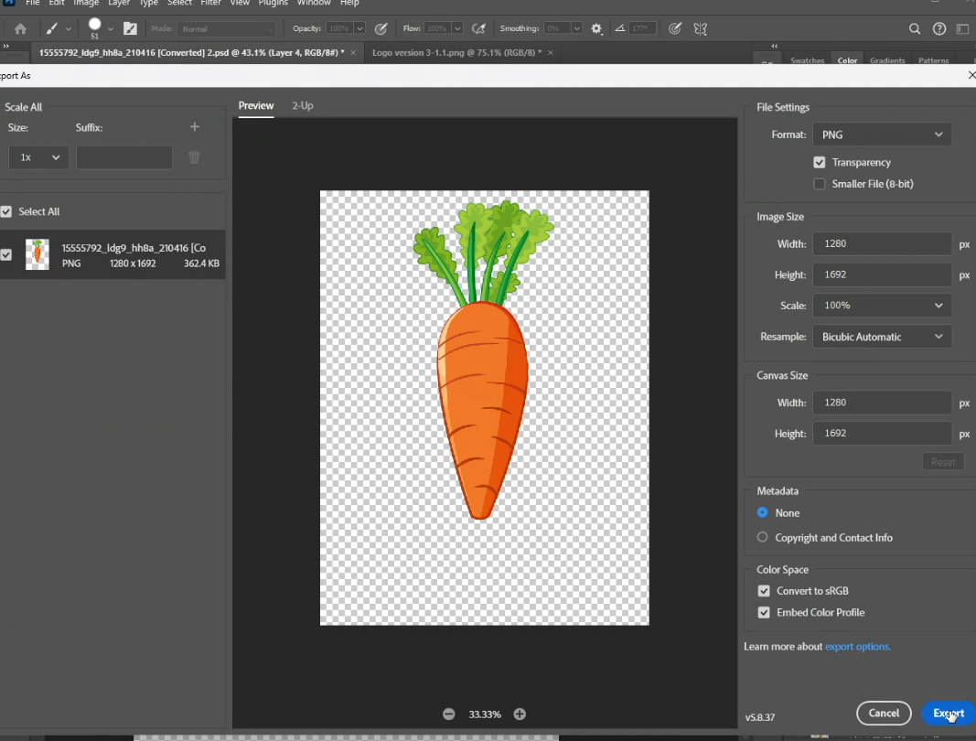

Figure 23: Screenshot 13

## 8.1 Post-Production

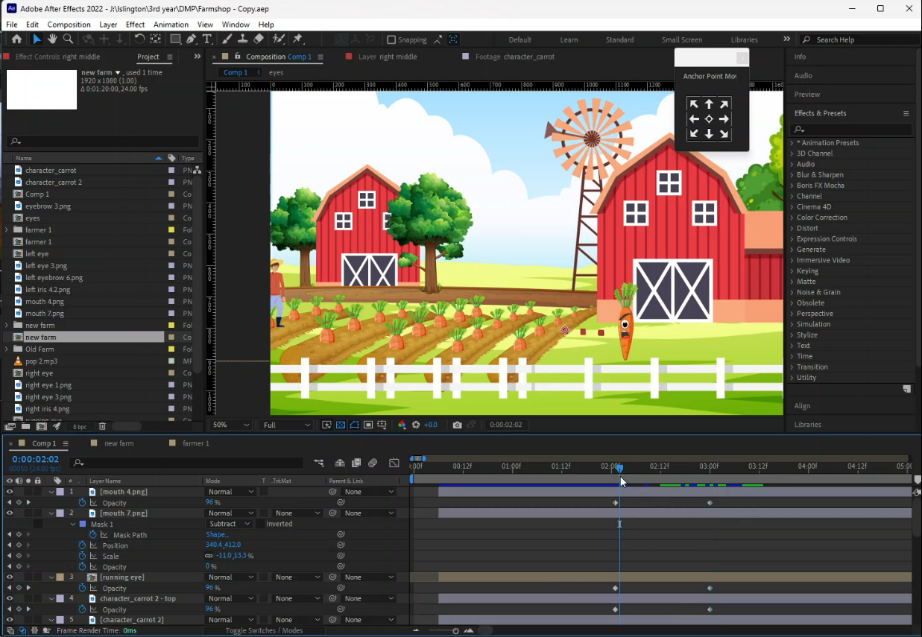

Figure 24: Screenshot 14

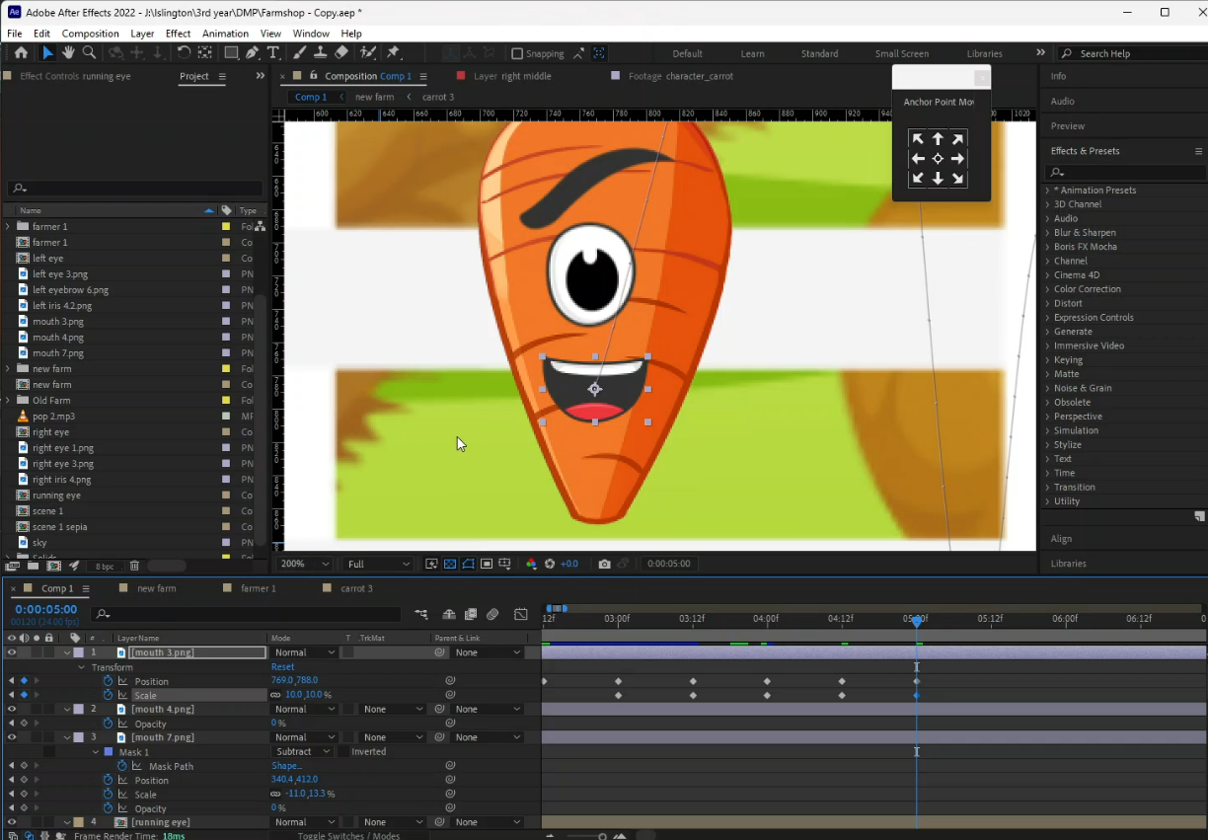

Figure 25: Screenshot 15

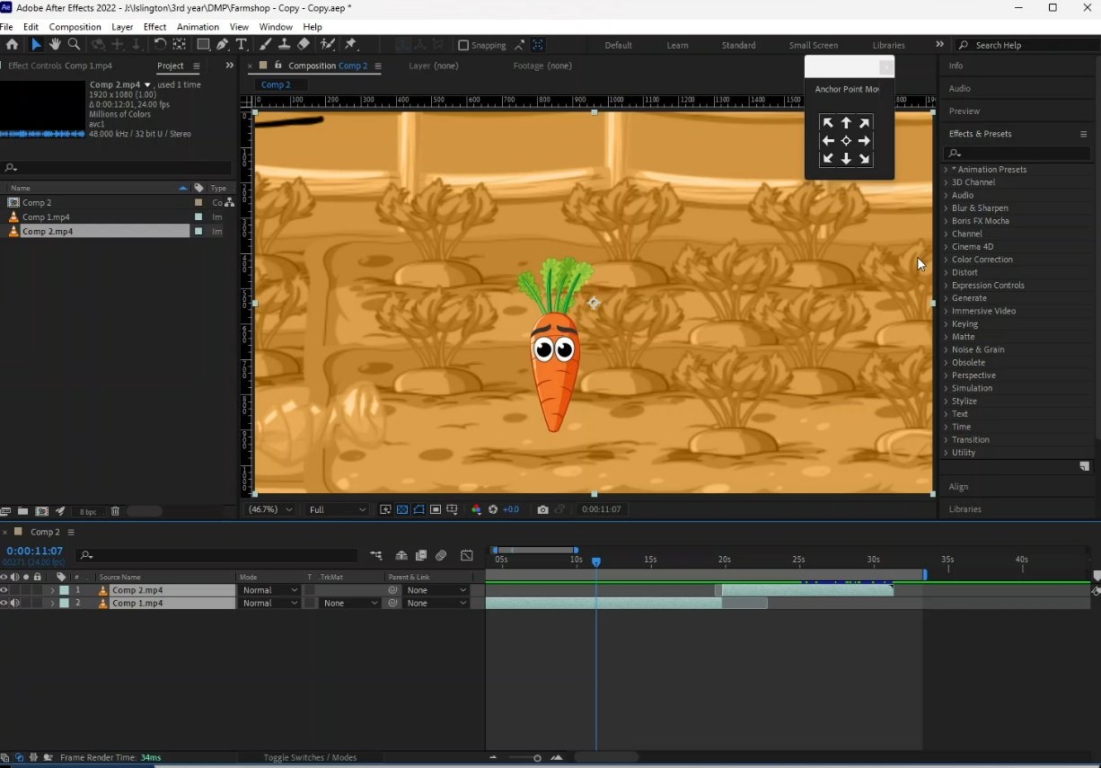

Figure 26: Screenshot 16

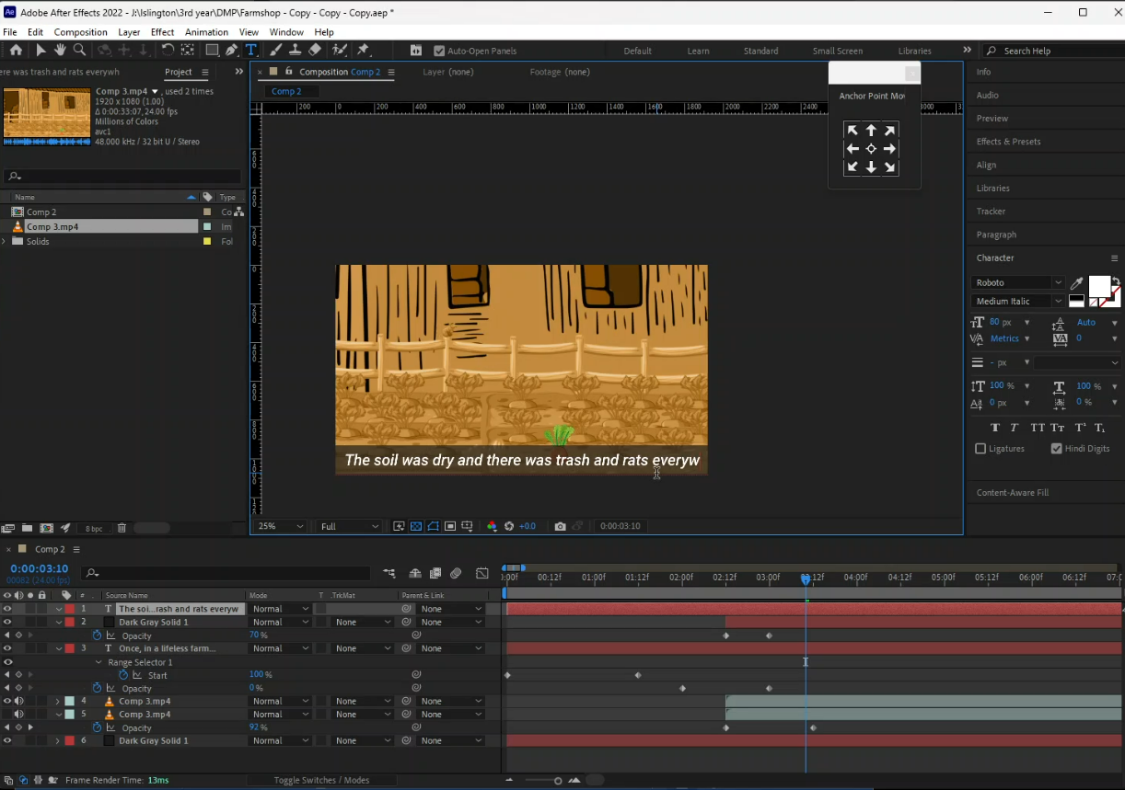

Figure 27: Screenshot 17

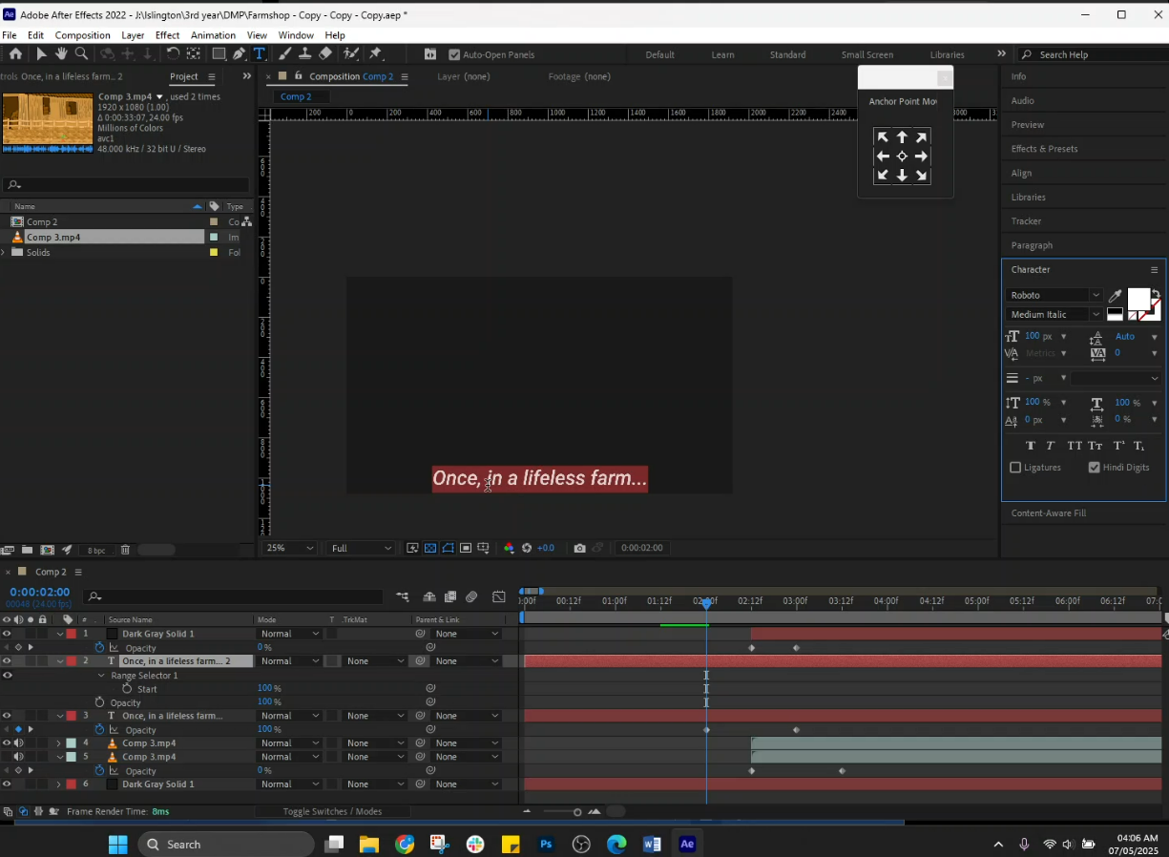

Figure 28: Screenshot 18

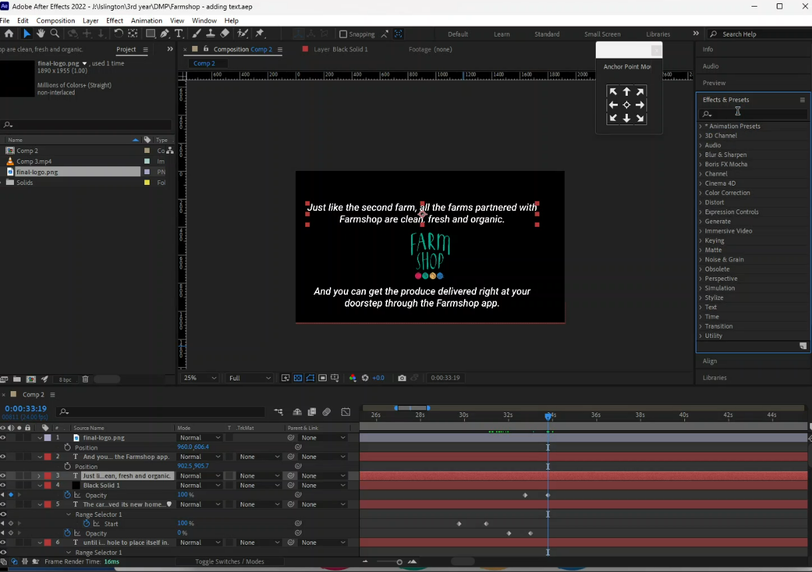

Figure 29: Screenshot 19

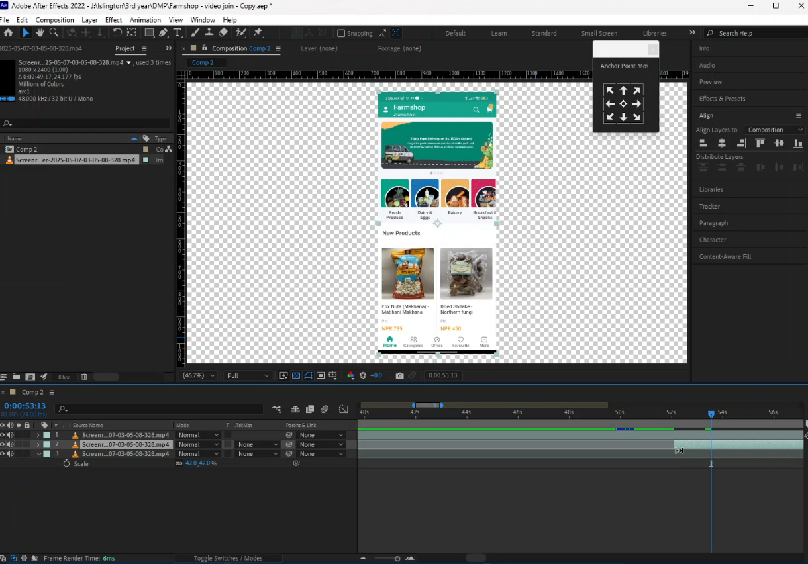

Figure 30: Screenshot 20

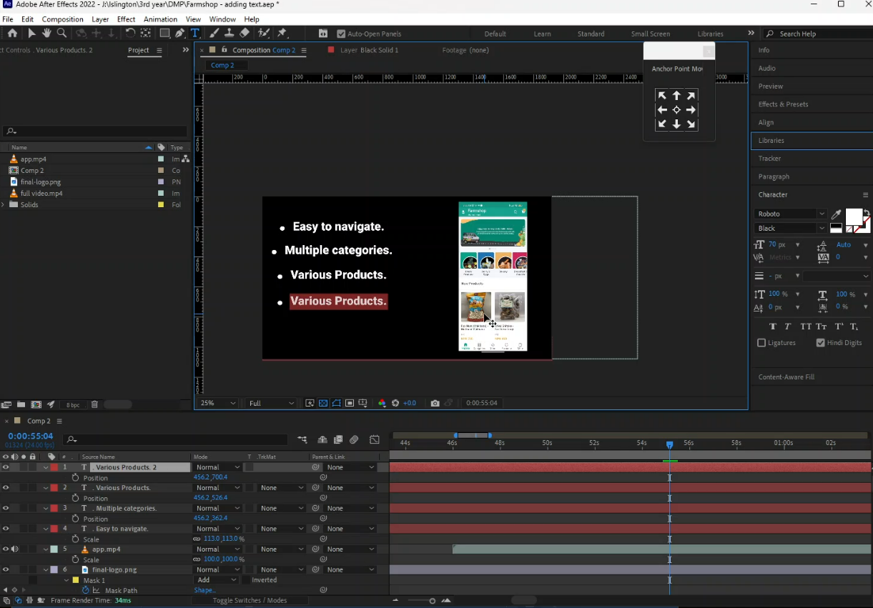

Figure 31: Screenshot 21

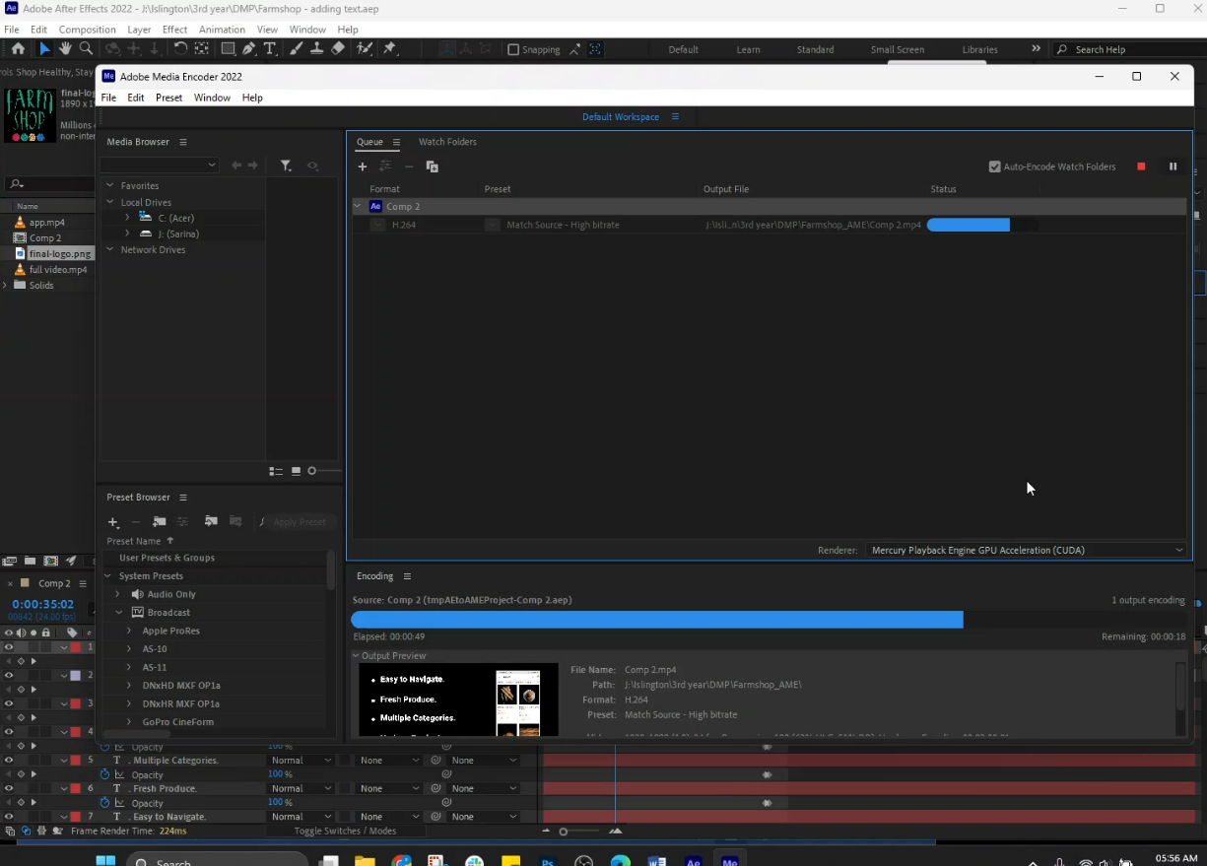

Figure 32: Screenshot 22

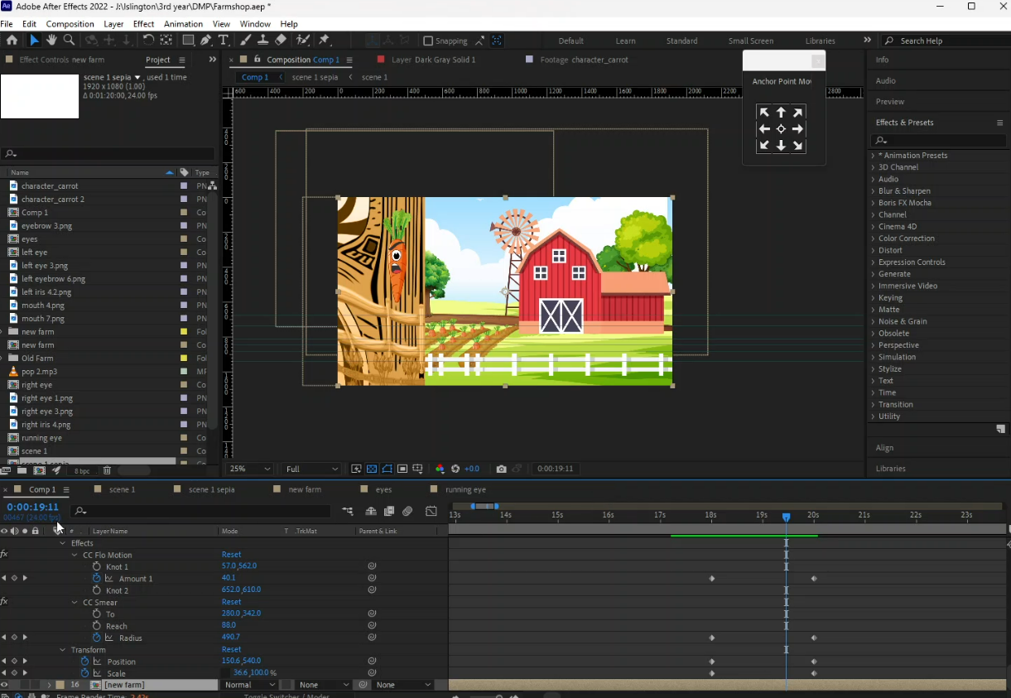

Figure 33: Screenshot 23

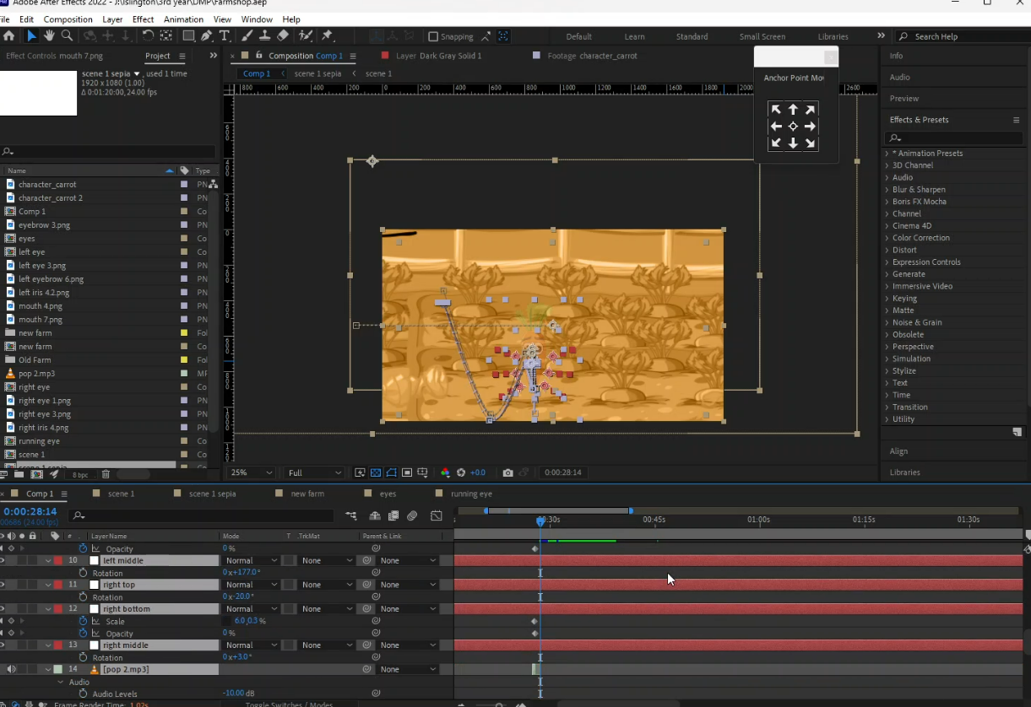

Figure 34: Screenshot 24

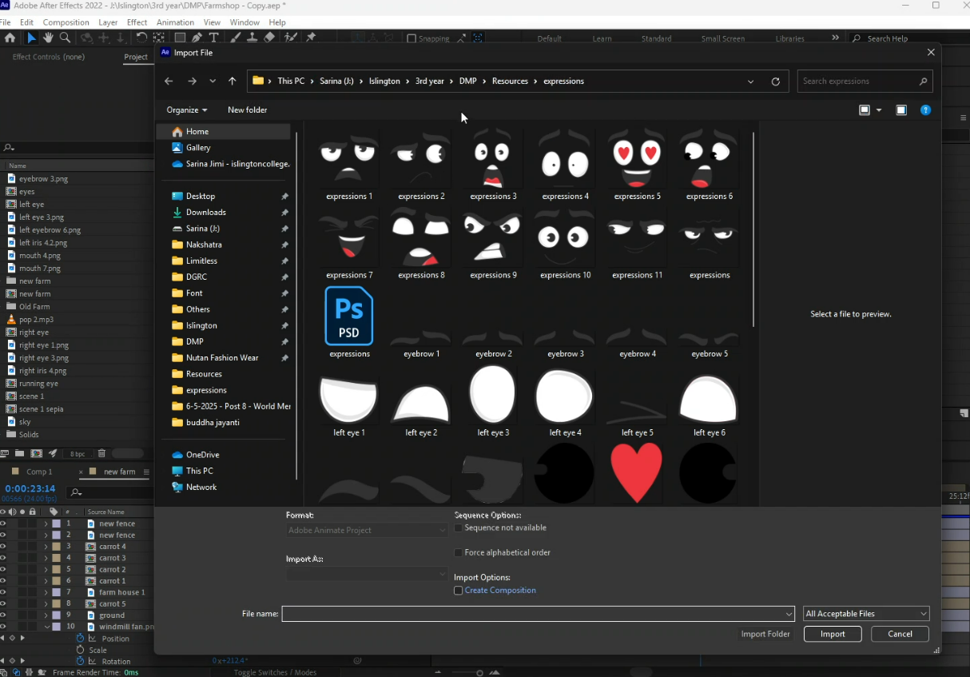

Figure 35: Screenshot 25

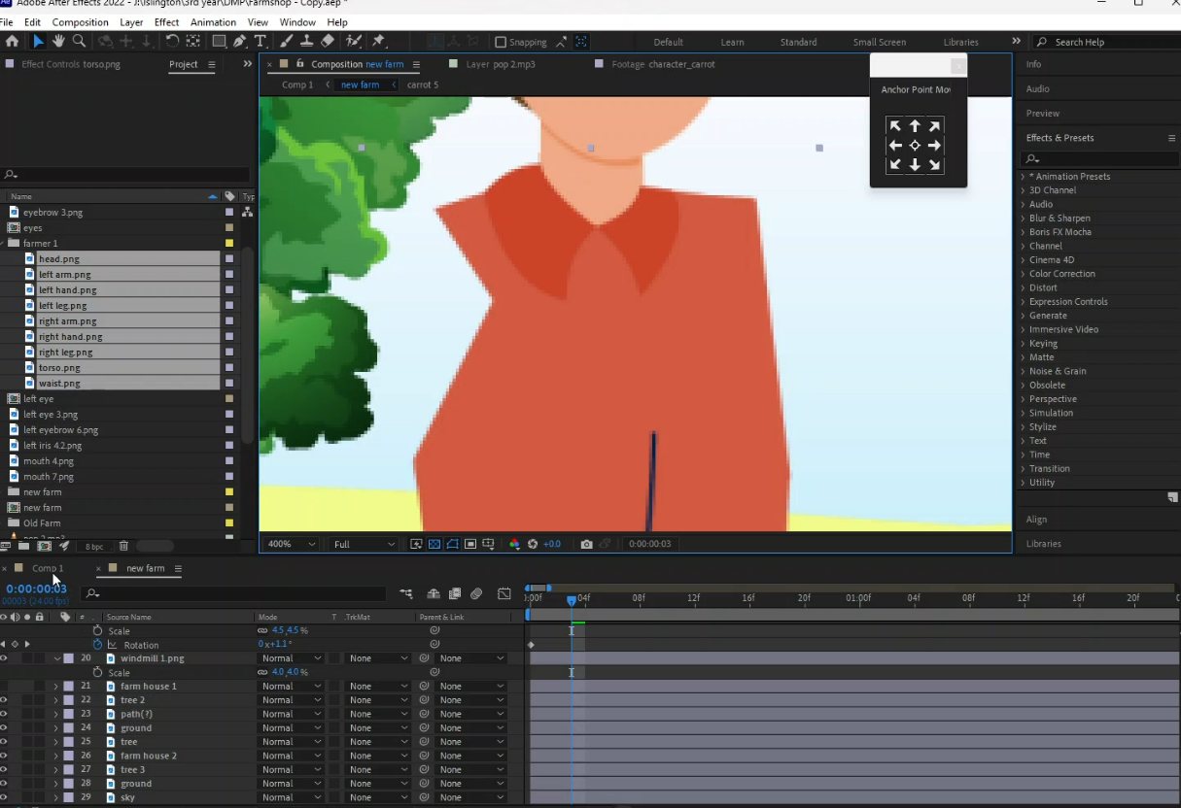

Figure 36: Screenshot 26

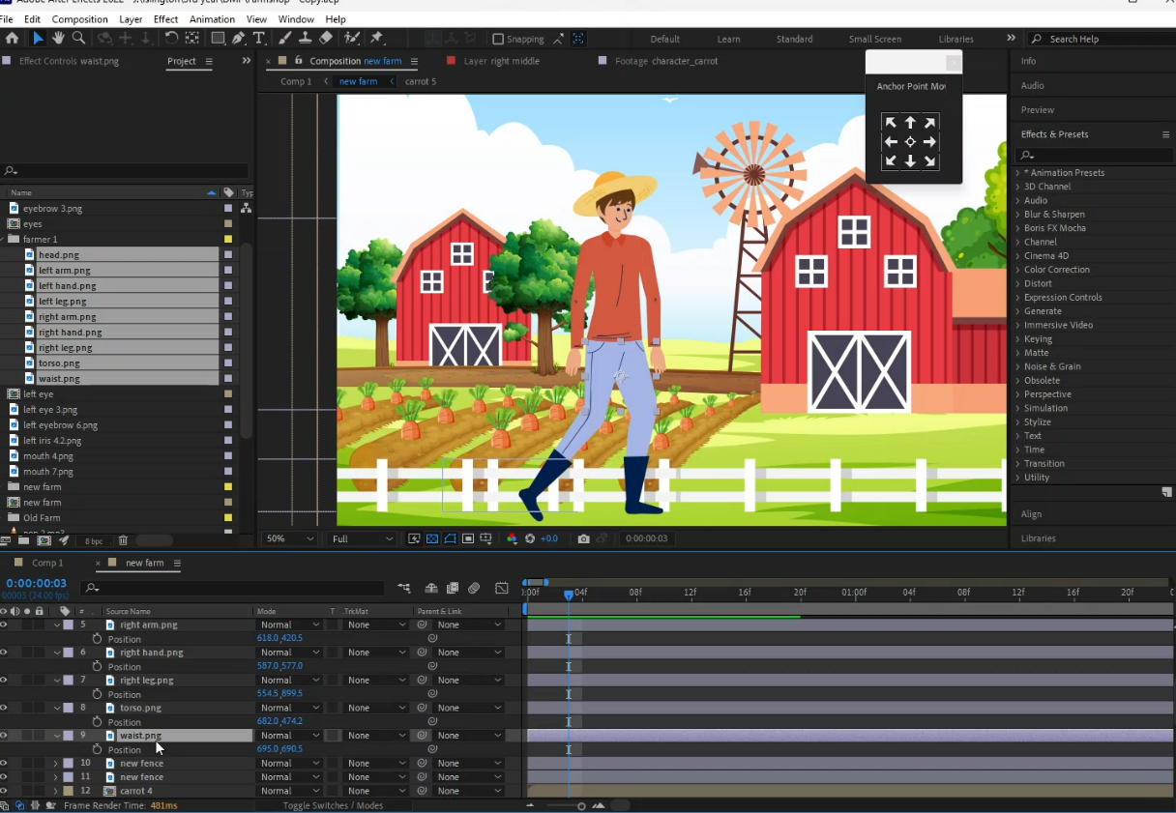

Figure 37: Screenshot 27

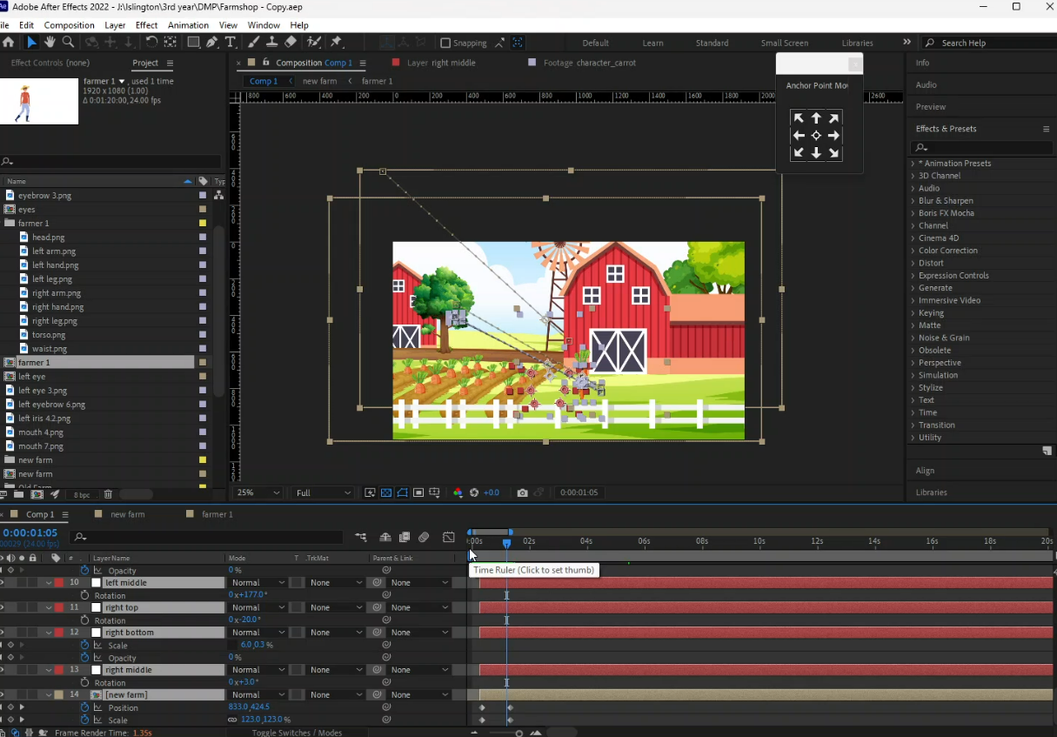

Figure 38: Screenshot 28

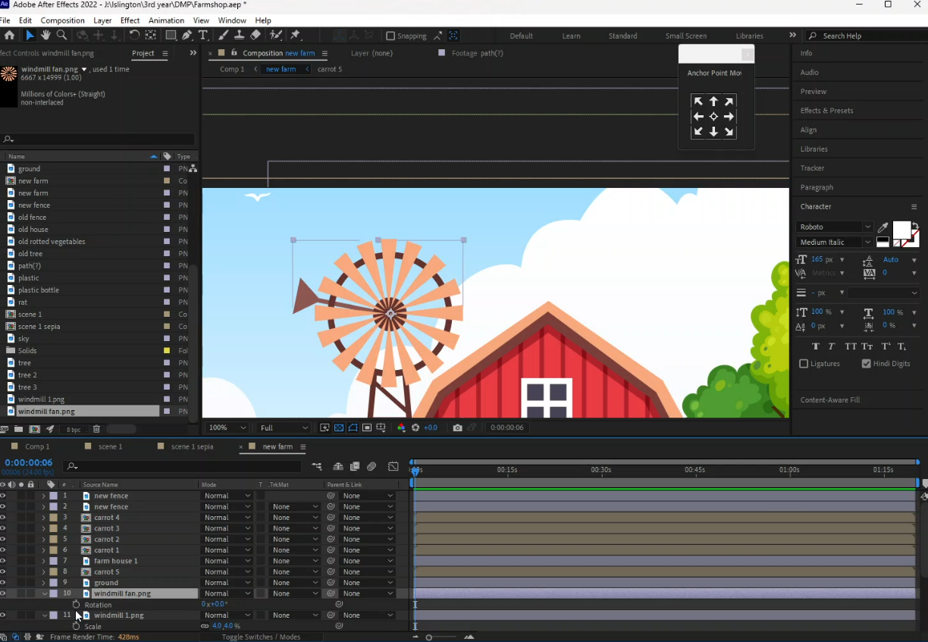

Figure 39: Screenshot 29

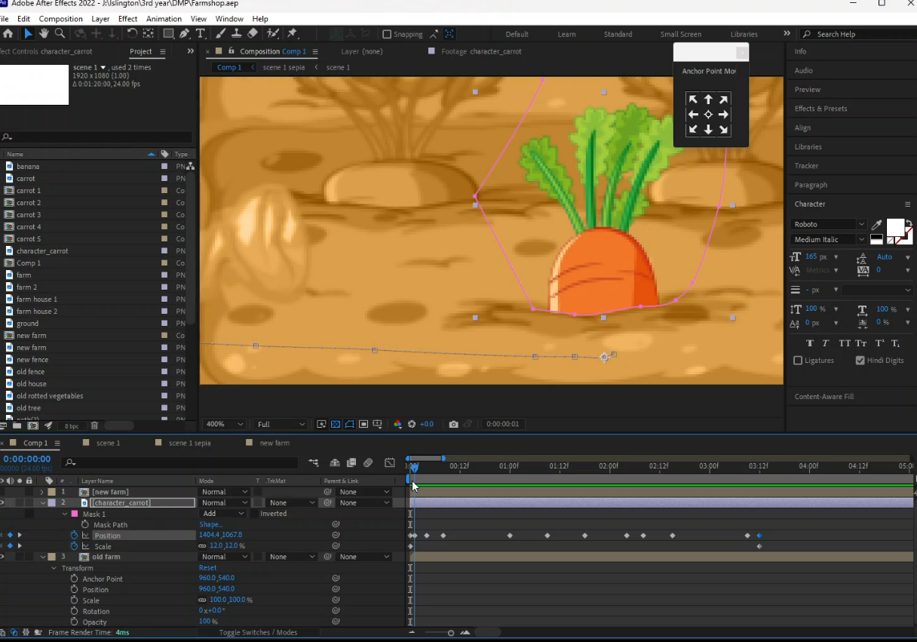

Figure 40: Screenshot 30

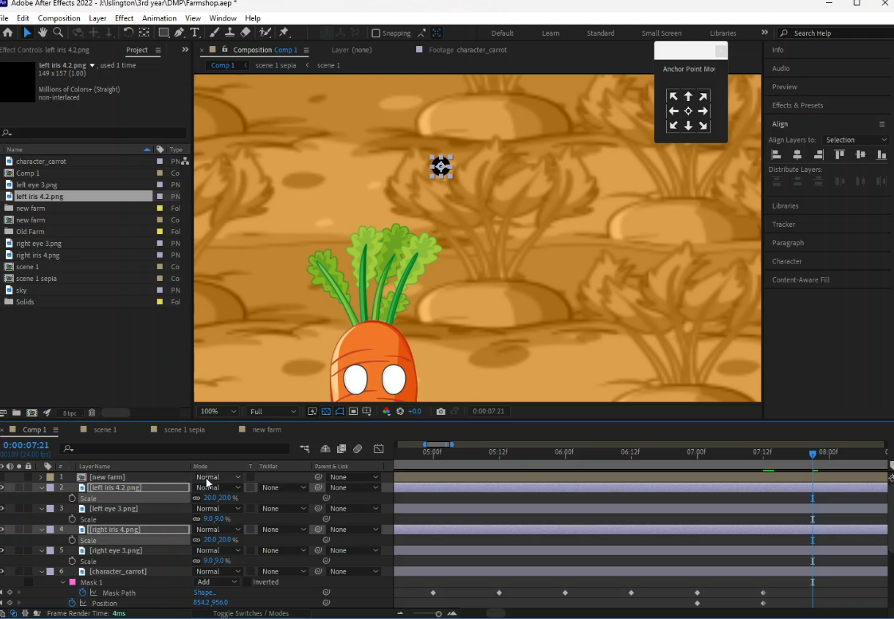

Figure 41: Screenshot 31

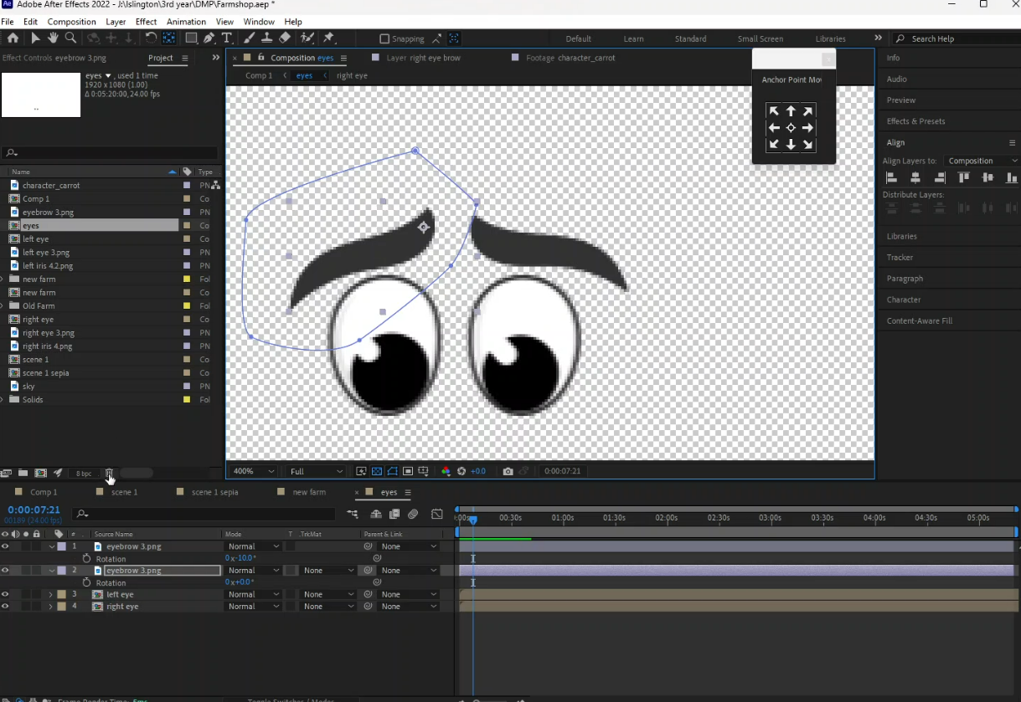

Figure 42: Screenshot 32

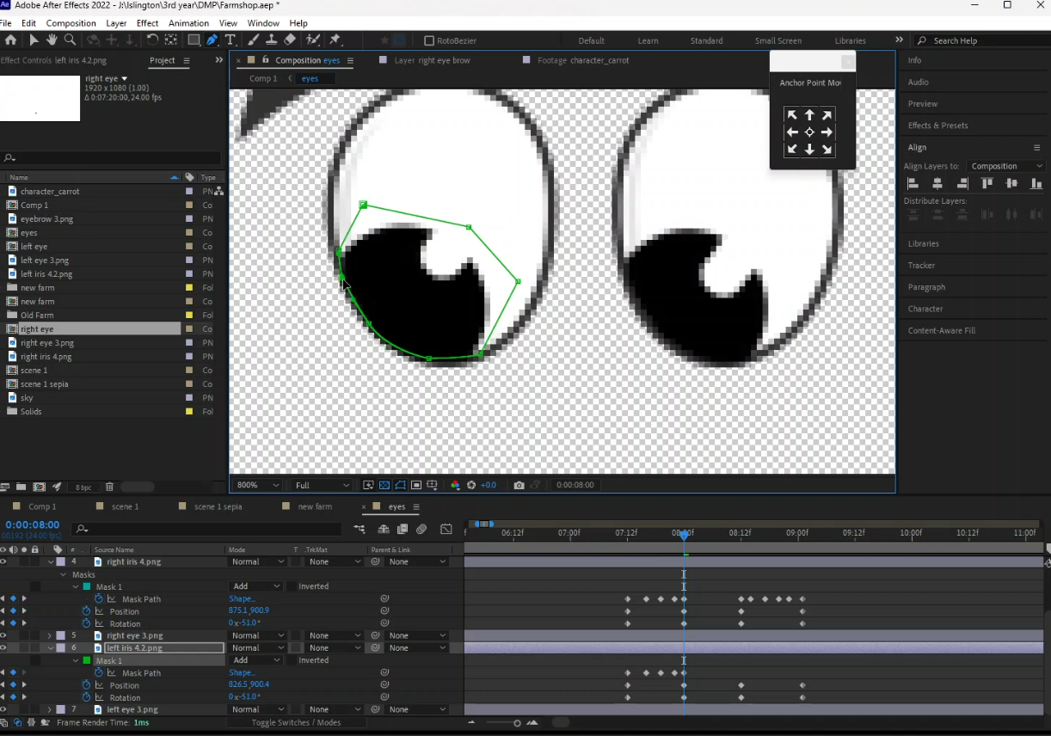

Figure 43: Screenshot 33

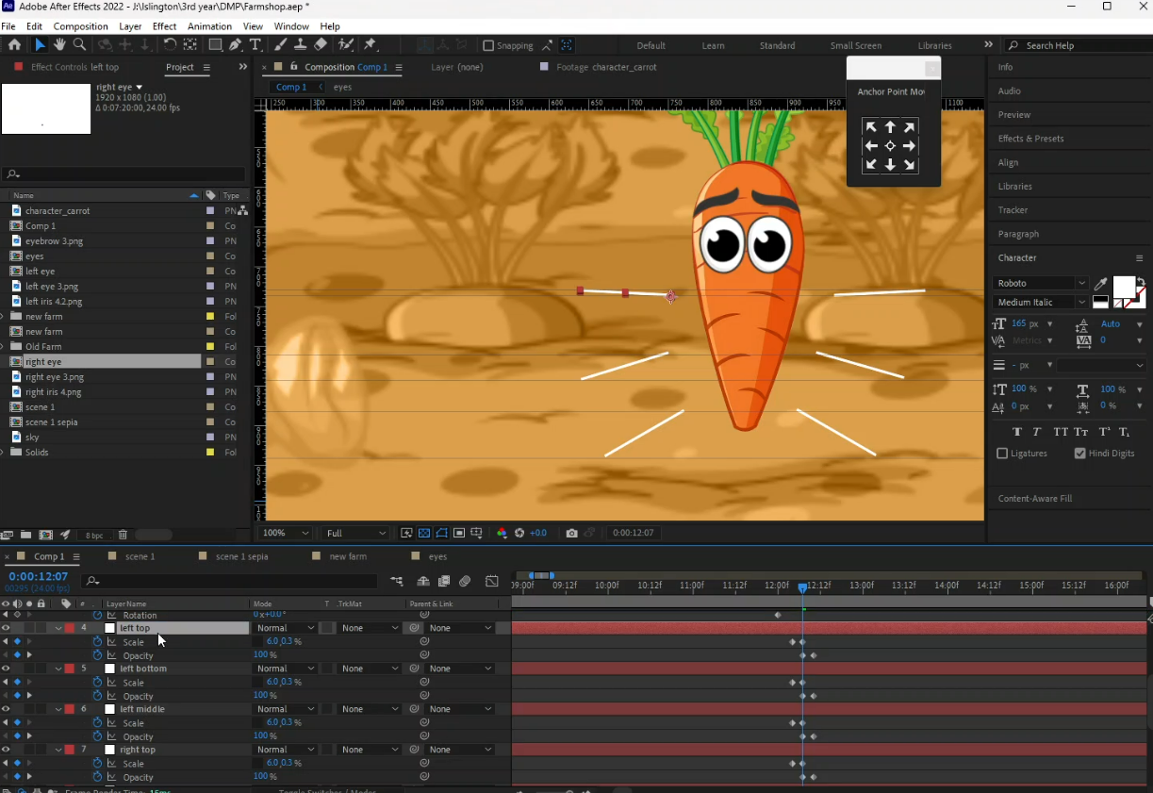

Figure 44: Screenshot 34

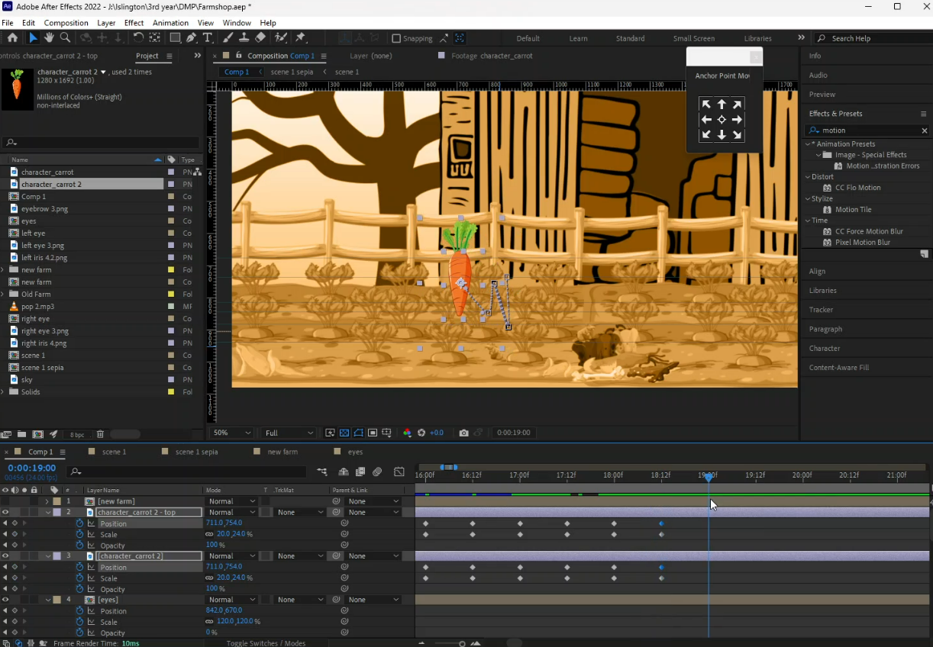

Figure 45: Screenshot 35

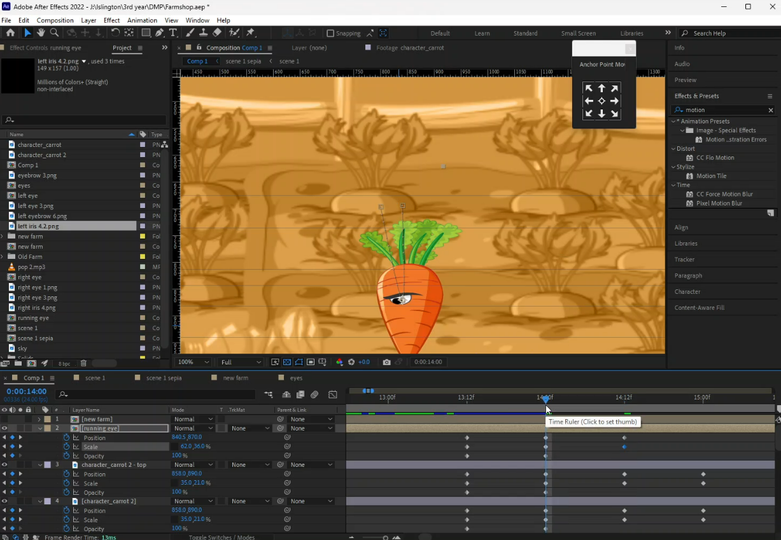

Figure 46: Screenshot 36

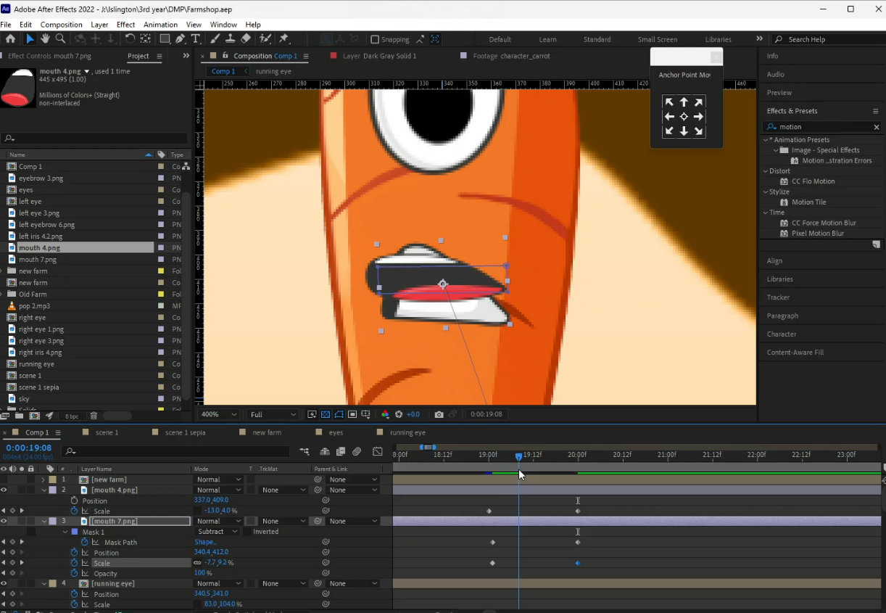

Figure 47: Screenshot 37

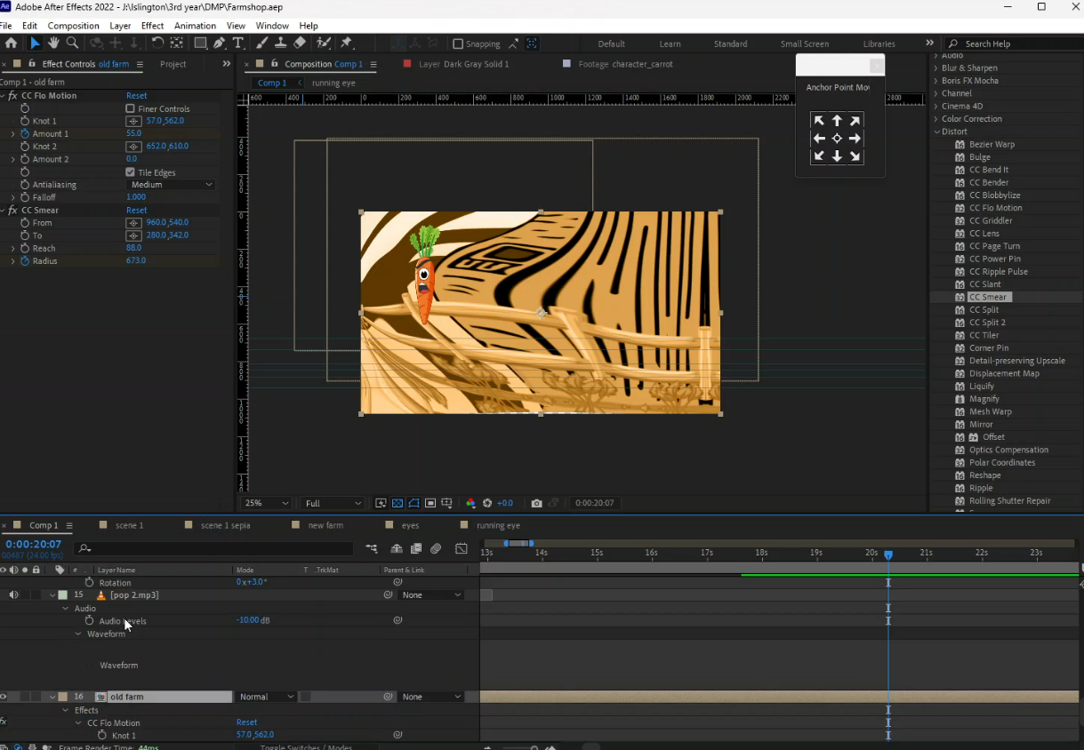

Figure 48: Screenshot 38

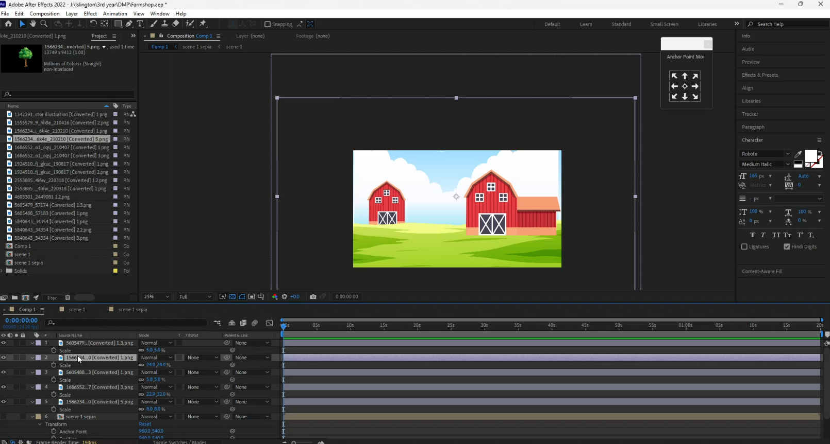

Figure 49: Screenshot 39

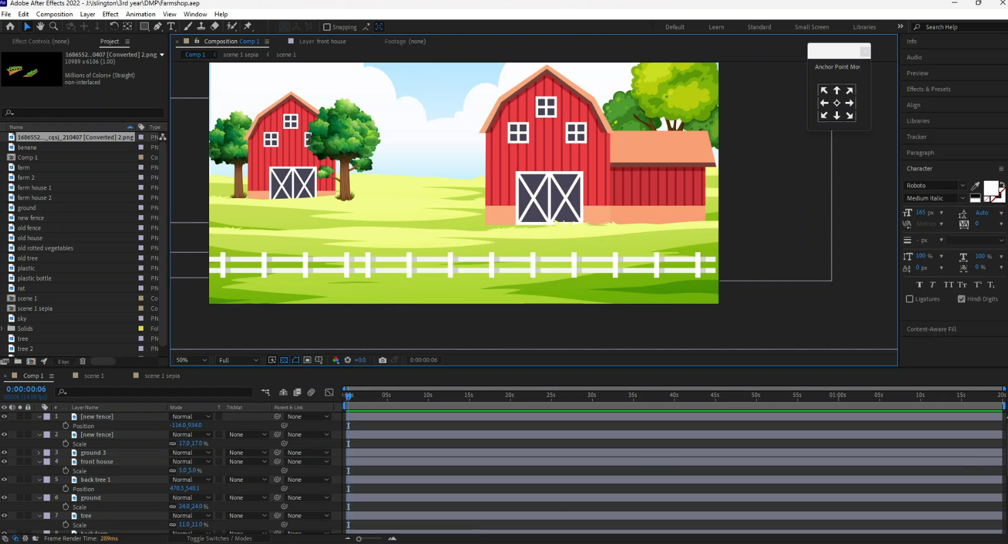

Figure 50: Screenshot 40

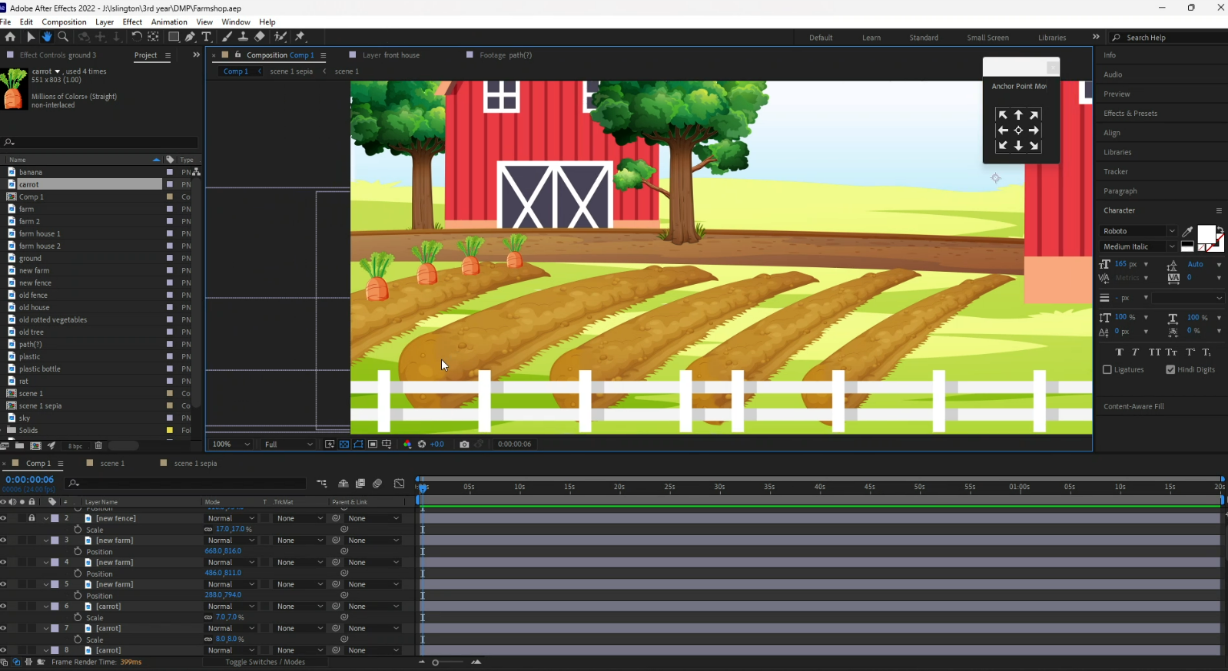

Figure 51: Screenshot 41

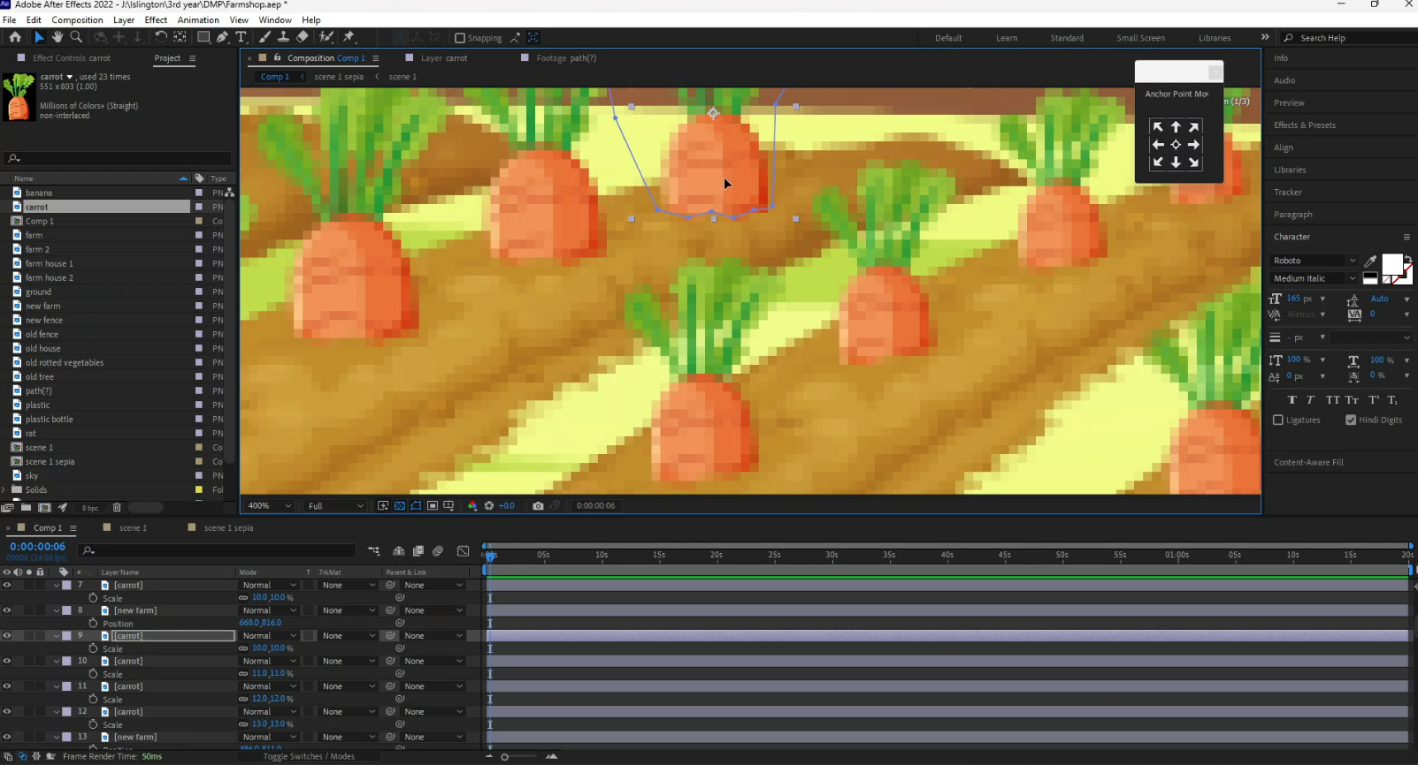

Figure 52: Screenshot 42

# 10. User Testing & Findings

## 10.1 Survey Form

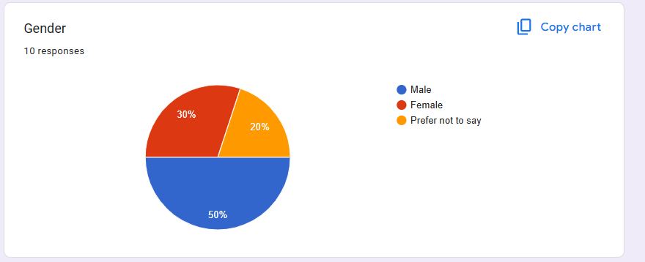

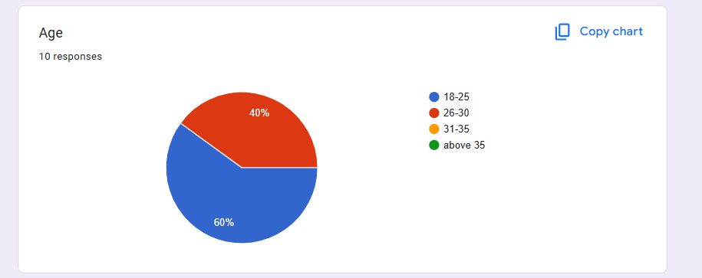

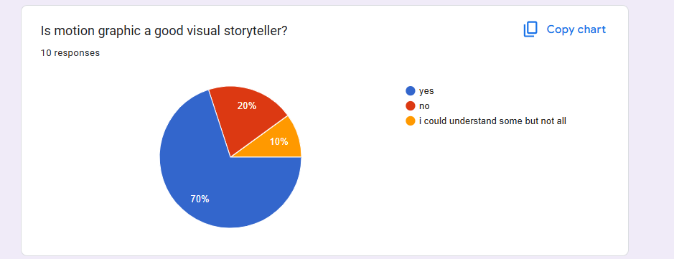

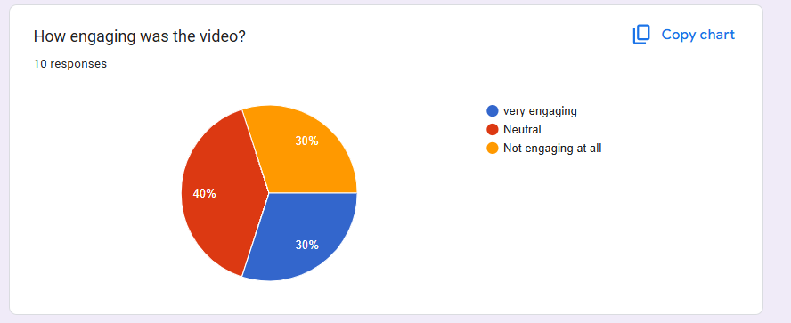

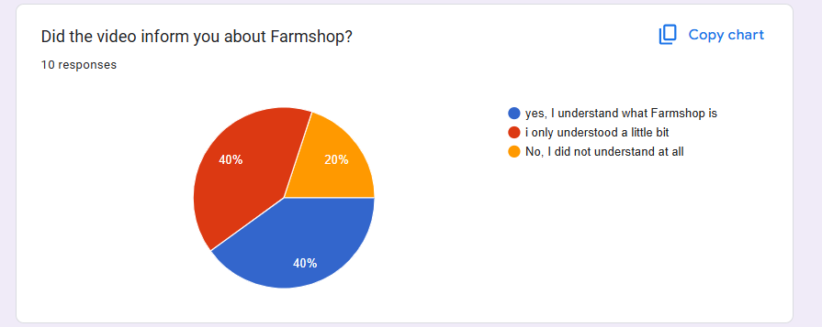

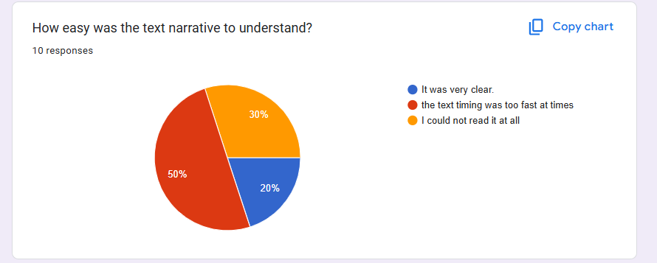

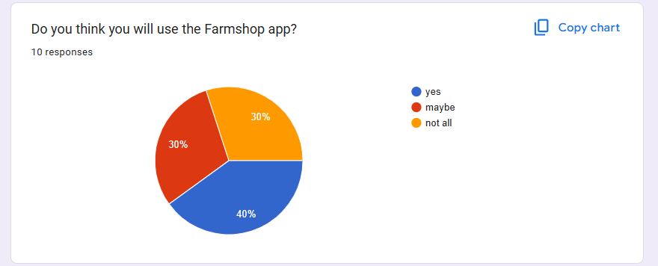

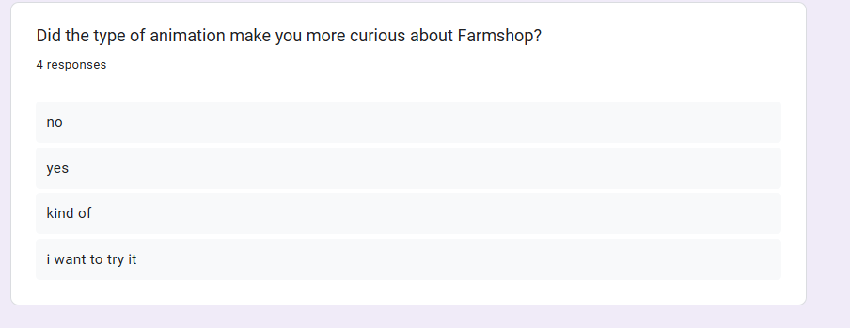

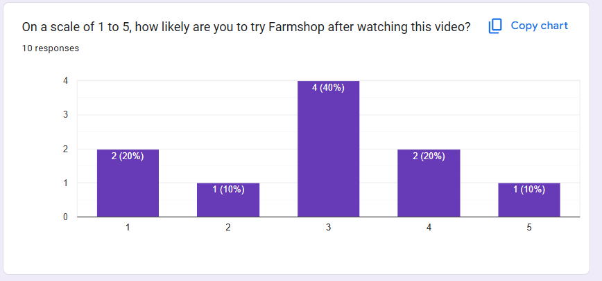

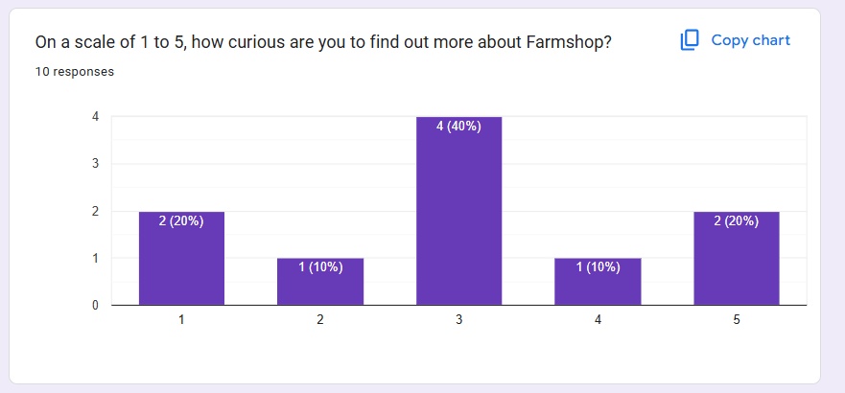

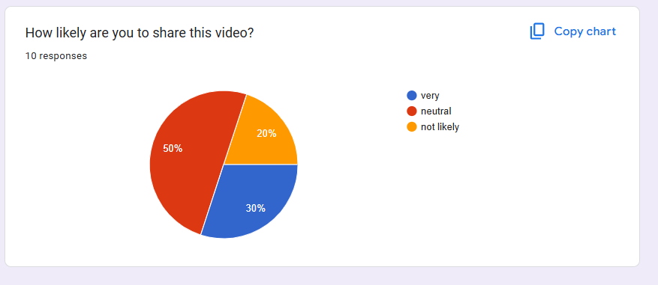

## 10.2 Survey Findings

The survey findings revealed that the majority of participants were young adults, with 60% aged between 18–25 and the remaining 40% in the 26–30 age group. In terms of gender, half of the participants identified as male, 30% as female, and 20% preferred not to disclose their gender. This indicates that the feedback came from a fairly diverse and relevant demographic for a digital app and media project.

Most respondents (70%) agreed that motion graphics served as a good visual storytelling method, showing the effectiveness of this medium. However, when asked about how engaging the video was, the responses were mixed: 30% found it very engaging, 40% felt neutral, and 30% did not find it engaging at all. This suggests that while the approach had potential, the delivery might not have connected equally with everyone.

When it came to understanding the purpose of the video, only 40% said they fully grasped what Farmshop was, while another 40% understood just a little, and 20% did not understand it at all. Additionally, the text narrative was a challenge for many, with 50% saying the timing was too fast and 30% stating they couldn’t read it at all—leaving only 20% who found it very clear.

Despite these limitations, 60% of viewers indicated some level of interest in using the Farmshop app—30% said yes, and another 30% said maybe. In terms of curiosity, most respondents rated their interest between 3 and 5 on a scale of 1 to 5, showing a mild to moderate curiosity about the app after watching the video. However, interest in sharing the video was low, with most responses leaning toward neutral or unlikely.

## 10.3 Third Party Evaluation

**Videographer**

**Name:** Alexander Gurung

**Feedback:** The Farmshop motion graphics video does a good job of showing the journey of fresh produce and promoting the app. The animation is smooth and visually appealing, but the pacing is a bit slow, and the text can be hard to read at times. Overall, it effectively conveys the message, though it could be more engaging with a faster pace and clearer text.

**Photographer**

**Name:** Puzan Dhakal

**Feedback:** The **Farmshop video** does a nice job explaining how the app works and showing the fresh produce. However, the video might benefit from more detailed visuals. It’s a solid start but could be improved with a bit more creativity and clearer explanations.

# Conclusion

In conclusion, this project successfully met its goal of creating an engaging and informative motion graphics video about Farmshop. The documentation explained different parts of the project, like the research, production steps, and target audience.

The research phase involved learning about motion graphic techniques and observing how Farmshop works in real life. The production process included writing the script, making a storyboard, animating, and editing. Each step was carefully done to make sure the final video looked good and worked well. Using creative storytelling and bright visuals, the video shows how Farmshop works and why it's useful. This also helps build awareness of the Farmshop brand.

Overall, the project made a short, fun, and helpful video that teaches people about Farmshop and shows how motion graphics can be used to share useful information in an entertaining way.

# References

CTA, 2020. *Digitalisation of Agriculture.* [Online]   
Available at: https://www.youtube.com/watch?v=g8tHedBgrRA  
[Accessed 1 November 2024].

Development, D. I. -. P. D. &., 2013. *Product Animation - 360° Rotation With Exploded Details.* [Online]   
Available at: https://www.youtube.com/watch?v=KMy6WFO0ugo  
[Accessed 15 November 2024].

Farming, E. F. &., 2017. *From farm to fork - sustainable food for our future.* [Online]   
Available at: https://www.youtube.com/watch?v=XAB7IO547tM  
[Accessed 24 November 2024].

Mundane, D. B. |. S. o. t., 2016. *Animated Logos: 5 Examples of “Stickifying” Your Brand.* [Online]   
Available at: https://medium.muz.li/5-powerful-examples-of-logo-animation-336f5b9f9168  
[Accessed 20 November 2024].

Provost, R., 2023. *What is Motion Graphics — Definition, Examples & Types.* [Online]   
Available at: https://www.studiobinder.com/blog/what-is-motion-graphics-definition/  
[Accessed 1 November 2024].

Splash, C., 2018. *Hydroponics Soi Farm | Explainer Video | Motion Graphics | By Creative Splash.* [Online]   
Available at: https://www.youtube.com/watch?v=BlEBeIbMIu4  
[Accessed 25 November 2024].

Storm, O., 2022. *Camera Moves in 2D animation - How its done.* [Online]   
Available at: https://www.youtube.com/watch?v=bMDq0f6VXqI  
[Accessed 23 April 2025].

Studio, H., 2023. *The Art of Animated Typography: Become a Pro in Transforming Words into Captivating Visuals.* [Online]   
Available at: https://hound-studio.com/blog/the-art-of-animated-typography-become-a-pro-in-transforming-words-into-captivating-visuals/  
[Accessed 15 November 2024].

Studio, R., 2018. *Best Explainer video of 2018.* [Online]   
Available at: https://www.youtube.com/watch?v=p7XwSF8NgsQ&t=10s  
[Accessed 17 November 2024].

Team, F., 2024. *The Art of Visual Storytelling in Marketing.* [Online]   
Available at: https://foundationinc.co/lab/visual-storytelling  
[Accessed 20 November 2024].

# Appendix



